Tech Support

*2015 El Segundo High School Roller Coaster Project*

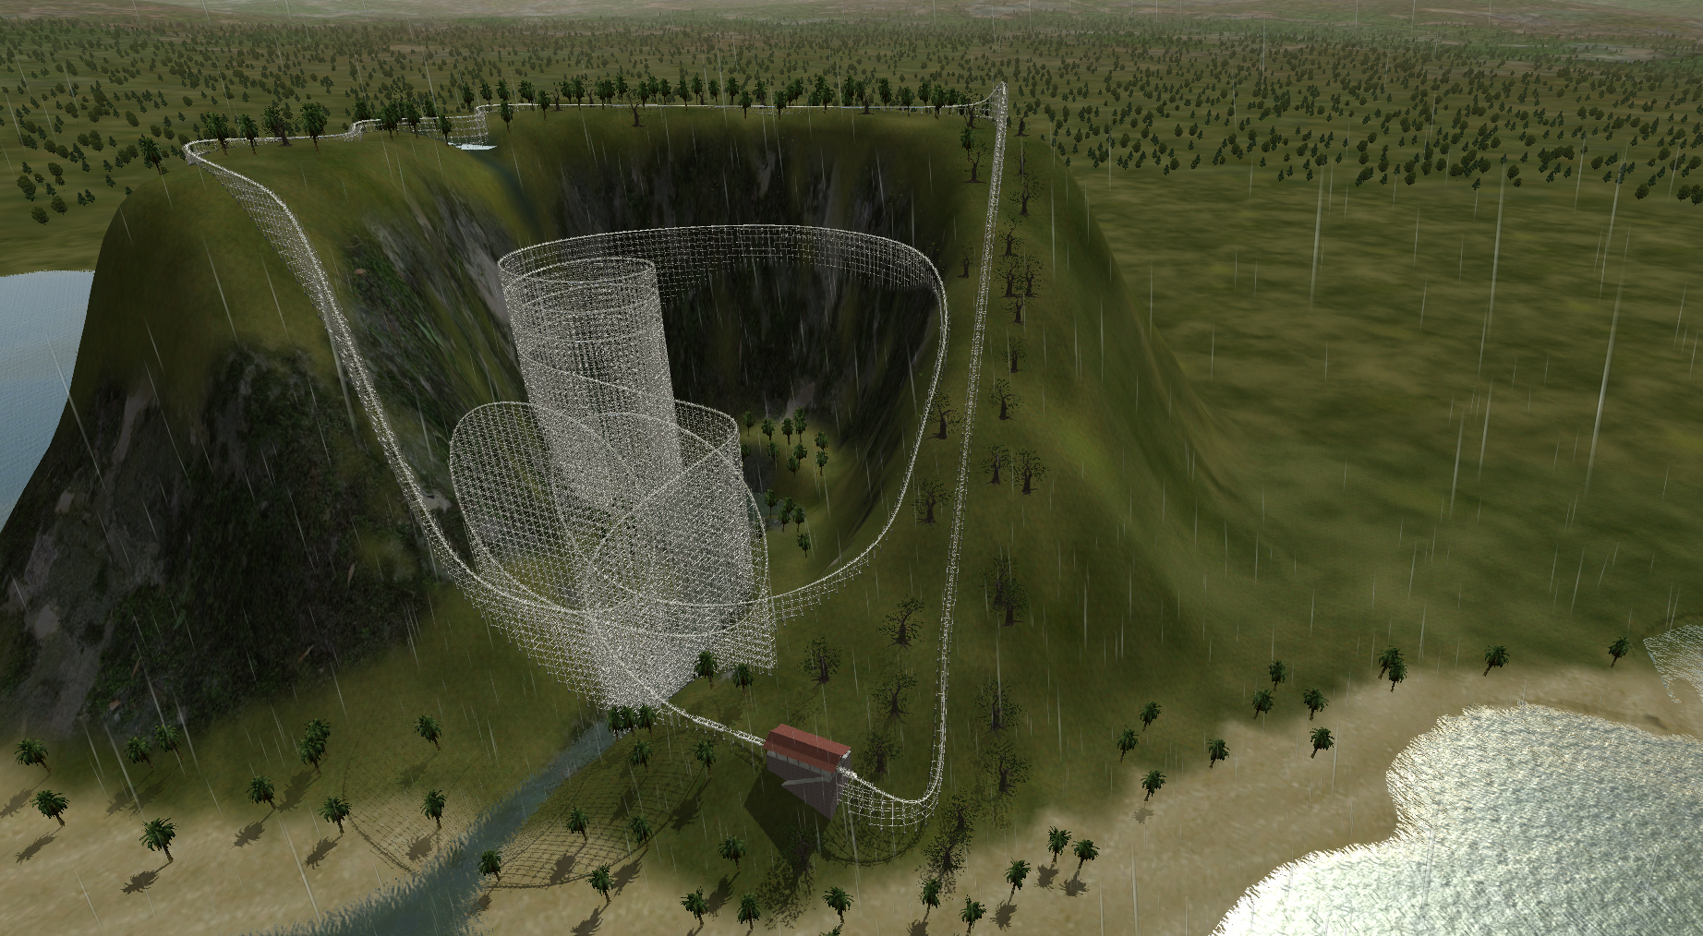

**Submitted By: PenIsland Squad**

|  |  |  |  |  |
| --- | --- | --- | --- | --- |
|  | Age | Grade | Phone Number | Email |
| Bradley Gallon (Technical) | 17 | 12 | (310) 906-6659 | bradleymoore007@gmail.com |
| Nick Mazuk (Systems) | 17 | 12 | N/A | trainridernick@gmail.com |
| Andrew Miyaguchi (Mechanical) | 17 | 12 | (424) 205-4718 | xdleader555@gmail.com |
| Elie Nehme (Manager/Business) | 17 | 12 | (310) 801-8097 | enehme46@gmail.com |

El Segundo High School

640 Main Street, El Segundo, CA 90245

(310) 615-2662

November 3, 2014

# Executive Summary

This report is a proposal by Pen Island Squad, for the bid of building a roller coaster on La Isla de Coca, in order to produce profit and increase education regarding the fields of Science, Technology, Engineering, and Mathematics. We accomplish this task through an original and abstract roller coaster, supporting the design with a complex computer simulation, giving us coordinate points, velocities, and timings along the entire track. We checked our work against international standards (such as EN 13814, the European code used by IAAPA.org, an amusement parks association). The proposed coaster would follow the theme of data management, the passage (and potential malicious action), and struggles of a single packet through the broad space known as the internet.

The coaster takes a sine wave down the top of the island waterfall, with a cubic function drop of about 120 meters. The coaster includes the required two loops right after the cubic function, which encounters a vertical G-Force of less than or equal to 9G’s. The coaster includes a spiral and an interlocking component which satisfies all constraints. In addition the coaster will be 90 cm x 78.3 cm which is well over the 50 cm x 50 cm constraint.

Our team aims to utilize our knowledge of STEM to produce a rollercoaster with an outstanding fun factor, amazing stability, and maxed speed while taking into account ecological factors, economical factors, and managing the best out of a very constrained project.

Overall, this report contains massive amounts of information regarding the literal design of the coaster, from specifics of (x,y,z) coordinates at any given moment, assuming a constant amount of time to ride the track at a specific size. We’ve taken many considerations to ensure accuracy, with a specific focus on not killing people (through extended durations of G-forces over 6 Gs). This track will not only satisfy but exceed given goals and ideals, while delighting the people riding, without hurting the local area.

Table of Contents

Executive Summary ii

1. Team Formation and Project Operation 8

1.1 Team Roles and Responsibilities 8

1.2 Project Operation 10

1.2 Tool Set-up / Learning / Validation 10

1.3 Hiring 12

1.4 Team Terms and Conditions 16

1.5 Meeting Log 19

1.6 Incident Report 27

2. Design 28

2.1 Design Process 28

2.2 Preliminary Designing 28

2.2.1 Selecting the Theme 28

2.2.2 Preliminary Sketches 32

2.2.3 Selecting the Design 34

2.3 Detailed Design 36

2.3.1 Detailed Dimensions 36

2.3.2 Bill of Materials 37

3. Business Case 39

3.1 Mission Statement 39

3.1.1 Product 39

3.1.2 Customers 39

3.2 The Case for Change 39

3.3 Scope 40

3.4 Project Implementation 40

3.4.1 External Communications and Stakeholders 40

3.4.2 Advertising Campaign 41

3.5 Legal Policy 41

3.6 Financial Appraisal 42

3.6.1 Costs Analysis 42

3.6.1.1 Construction Cost Analysis 42

3.6.2    Revenue Analysis 43

3.6.2.1 Comparative Revenue Analysis 43

3.6.2.2 Revenue Projections 44

3.7 Economic Appraisal 44

4. Ecological Impact 46

4.1 Executive Summary 46

4.2 Analysis 46

4.3 Potentially Affected Species 47

4.3.1 *Flora* 47

4.3.2 *Fauna* 48

4.4 Mitigation Policy 49

5. Physics Analysis 50

5.1 Rectilinear Motion Calculations 50

5.2 Energy Calculations 53

5.3 Free Body Diagrams 54

6. Testing and Building Methods 58

6.1 Testing 58

6.1.1 Marbles 58

6.3 Failure Analysis 64

6.3.1 Straw Failure 64

6.3.2 Bonding Methods 66

7. Mathematical Analysis 69

8. Design Validation 70

8.2 IAAPA Constraints 72

8.3 Ecological Constraints 78

9.0 Theoretical Vs. Actual 80

6. Resources 82

List of Figures

Figure 1: NoLimits Coding 12

Figure 2: Potential Design 1 33

Figure 3: Potential Design 2 33

Figure 4: Potential Design 3 34

Figure 5: Potential Design 4 35

Figure 6: Potential Design 5 35

Figure 7: Roller Coaster Dimensions 37

Figure 8: Mins/Maxes Along the Z-Axis 38

Figure 9: Horizontal X position (m) at time t 51

Figure 10: Horizontal Y position (m) at time t 51

Figure 11: Vertical Z position (m) at time t 52

Figure 12: Vertical X position (m) at position Y 52

Figure 13: Horizontal Y position (m) at position X 52

Figure 14: Horizontal X Velocity (m/s) at time t 53

Figure 15: Horizontal Y velocity (m/s) at time t 53

Figure 16: Vertical Z velocity (m/s) at time t 53

Figure 17: Velocity (m/s) at time t 54

Figure 18: Horizontal G-force at time t 54

Figure 19: Vertical G-force at time t 54

Figure 20: Potential Energy vs. Time 55

Figure 21: Linear Kinetic Energy vs. Time 55

Figure 22: Rotational Kenetic Energy vs. Time 55

Figure 23: Free Body Diagram Top of the Loop 56

Figure 24: Free Body Diagram Entrance of the Loop 56

Figure 25: Free Body Diagram Exiting the Loop 57

Figure 26: Free Body Diagram Top of Drop 57

Figure 27: Free Body Diagram Bottom of the Drop 58

Figure 28: Efficiency Test Set-up 62

Figure 29: Efficiency Test Acceleration Calculation 65

Figure 30:F2291 - 06a - Fig. 11 75

Figure 31:F2291 - 06a - Fig. 12 76

Figure 32:F2291 - 06a - Fig. 13 76

Figure 33:F2291 - 06a - Fig. 14 77

Figure 34:F2291 - 06a - Fig. 15 77

Figure 35:F2291 - 06a - Fig. 16 77

Figure 36:F2291 - 06a - Fig. 17 78

Figure 37:F2291 - 06a - Fig. 18 78

List of Tables

Table 1: Gantt Chart 11

Table 2: Theme Decision Matrix Part 1 30

Table 3: Theme Decision Matrix Part 2 31

Table 4: Design Decision Matrix Part 1 36

Table 5: Design Decision Matrix Part 2 36

Table 6: Bill of Materials 39

Table 7: Construction Costs 43

Table 8: Coaster Revenue Statistics 44

Table 9: Marble Diameters and Masses 60

Table 10: Marble Diameter Statistics 61

Table 11: Efficiency Test Times 63

Table 12: Efficiency Test Statistics 64

Table 13: Straw Failure Results 66

Table 14: Bonding Methods Results 68

Table 15: Bonding Methods Statistics 69

# 1. Team Formation and Project Operation

## 1.1 Team Roles and Responsibilities

Elie Nehme

*Project/Business Manager*

My specialty is the human element. I love information with a passion and am deeply interested in the social forces/relations that support modern society. I prefer to seek out the human perspective from seemingly impersonal processes, and enjoy analyzing the underlying social, economic, and legal trends of human history and their relationship with human development. The responsibilities and duties of my position include, but are not limited to:

* Setting team goals and coordinating efforts to achieve them.
* Maximizing productivity by mediating internal disputes
* Harmonize work conditions by providing snacks and reserving break time to reduce “burnout.”
* Maintaining morale through a calm yet passionate attitude.
* Taking lead on the business case
* Creating the Gantt chart and ensuring the group stays on schedule
* Maintain meeting schedules

Nick Mazuk

*Lead Systems Engineer*

After the gauntlet of engineering that the Real World Design Challenge presents, I have gained valuable experience integrating several design components into one design. While already a project manager on several projects—such as the aforementioned Real World Design Challenge as well as the capstone project for Engineering Design and Development—systems engineering will allow me to transfer my developed skills of managing people to managing systems.

* Ensure that all members complete their tasks
* Ensure that all components work together
* Ensure a high quality of work
* Help make sure the product has a consistent look and feel

Bradley Gallon

*Lead Technical Expert*

A fine example of humankind, I am a passionate mathematician who enjoys algorithms and functionality while understanding the rationale behind life. I enjoy building with legos, making computers give me numbers I want, and have fun finding shortcuts in mathematical operations. With large amounts of experience in programming and teaching, the skills to build an online, theoretical, and working model of a calculator.

* Completes the mathematical calculations
* Ties in the model with the physics
* Ensures that the coaster meets the requirements related to math and physics
* Helps refine the design
* Completes the Spanish portion
* Ensures the citation is accurate and complete
* Working on the internet integration with Andrew
* Team DJ

Andrew Miyaguchi

*Lead Mechanical Engineer*

I love technology. I’m going to major in computer science, but I have a background in electrical and mechanical engineering as my hobbies include mainly working with my hands. I enjoy learning about electronics on my own through soldering, breadboarding, programming, or even tearing down old electronics. Also, I have interned at Northrop Grumman as the Mechanical Test Intern

* Leads the building
* Completes the CAD model on No Limits
* Coordinating the materials
* Working on the internet integration with Bradley

Janna Lao

*General Assistant and Business Consultant*

I specialize in business concepts and planning as well as lending a helping hand. I love to work with my hands and get a beautiful project finished with pristine results. My business experience in Career Readiness, internships, job observations gives me more knowledge on how to go about expressing goals and intentions in a concise and efficient manner.

* Available and efficient labor, for whichever tasks are needed (assisting Andrew and Bradley in building)
* Experience handling business cases and large reports
* Originality and creativity, beneficial for bouncing ideas off of
* Positive and enthusiastic attitude for raising the energy of the group
* Providing an artistic and feminine touch to this otherwise nerdy male group

## 1.2 Project Operation

To keep the project running smoothly, we created an initial contract which we and all our parents/legal guardians signed. This included scheduling, termination, misconduct, as well as other potential issues, and will serve as the organizational template for our enterprise. The current edition of the contract is located in Appendix C: Team Terms and Conditions.

In addition, we created a Gantt chart to plan out the entire project timeline. Up to this point, we have successfully stayed with the Gantt chart with a couple exceptions due to unforeseen delays. We have, however, always been able to catch up after each of these delays.

Table : Gantt Chart

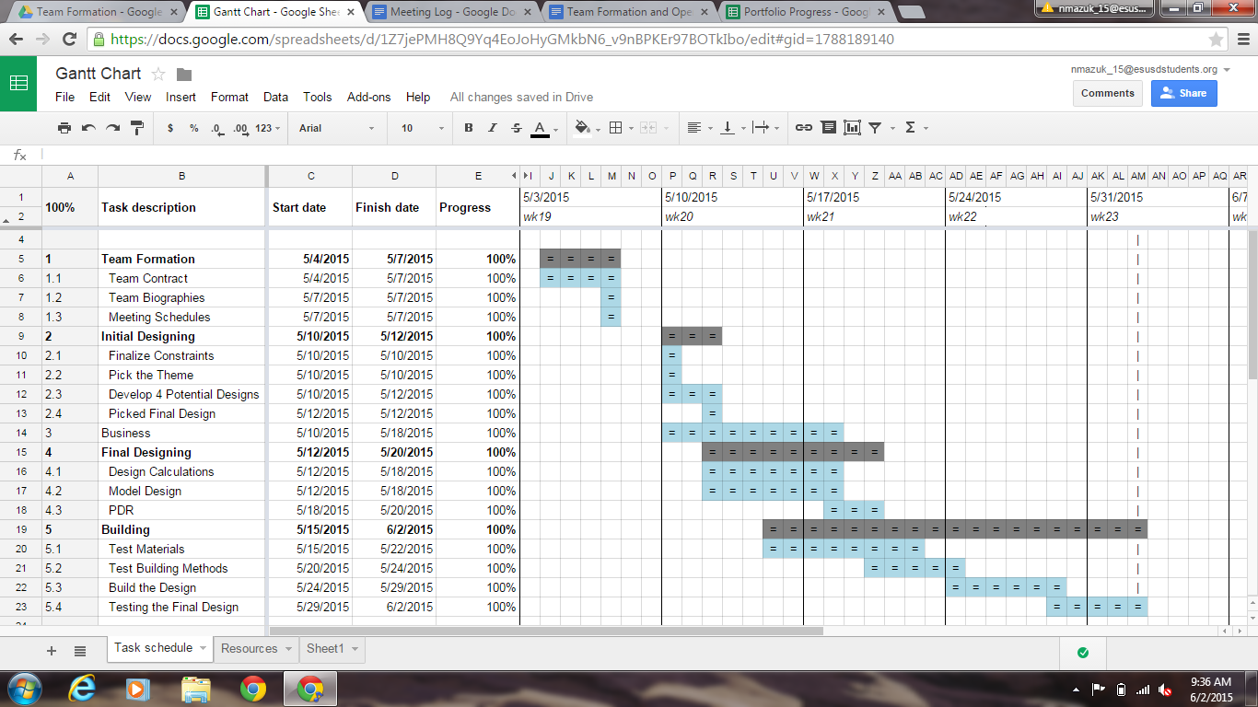

## 1.2 Tool Set-up / Learning / Validation

The required tools for this project were provided by our engineering teacher, Mr. Eno. The main program employed for design, simulations, and testing was Nolimits 2 (NL2). Andrew Miyaguchi was chosen to learn NL2 as quickly as possible to create an accurate model of the roller coaster. Installing the software was simple, using the key provided by our engineering teacher. The more difficult part of the process was to actually learn how to use it. The learning curve for NL2 was not too steep, as the controls resembled a modern gaming console. Getting started, on the other hand, required an analysis of the tutorial and help manuals to fully comprehend and operate NL2.

Autodesk Inventor is a 3D CAD modeling software which was used to create 3D parts to help with the build side of the project. Much of the CAD modeling skill required was already learned due to engineering courses at the local high school.

We initially planned to model the rollercoaster using Autodesk Inventor, but after realizing the time and energy required using a CAD modeling software the team reconsidered its options and instead used a roller coaster software program.

NL2 contained everything needed to validate any calculations made on the real life coaster, but for theoretical planning data logging was needed in order to create accurate graphs and functions. Because of a limitation in the Nolimits 2 Simulation program, the team was unable to efficiently log data. A program called CheatEngine was used to directly read values from the simulation program and log all the data onto a console. This required specific memory addresses to be located before any data logging could begin.

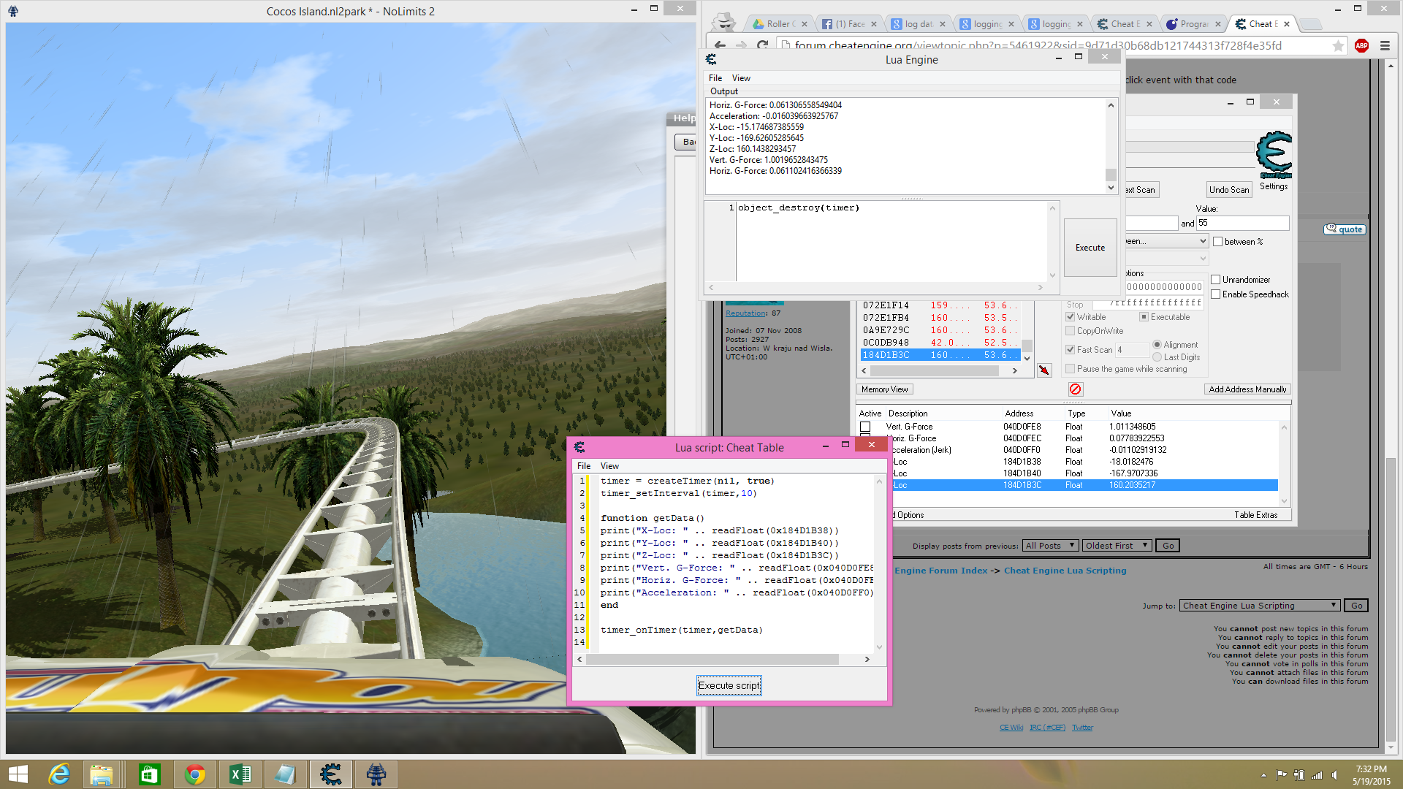

Figure : NoLimits Coding

Certain memory addresses were easy to locate, as the “F2” key on any generic keyboard opens up the simulations panel that describes the vertical, horizontal, and jerk G-Forces. CheatEngine includes a function to search for values between two numbers, which complements NL2’s ability to save values as floats. Once the values are found, the memory address is saved in a different box for reference in the program used to log the data.

The programming language used to log the data from CheatEngine is Lua. CheatEngine includes its own Lua scripting engine, which the team utilized to log data onto the console. The quick and simple program can be found below:

timer = createTimer(nil, true)

timer_setInterval(timer, 10)

function getData()

print("Time: " .. readFloat(0x140e04c64)) -- “..” acts as concatenation

print("X-Loc: " .. readFloat(0x23e8b178))  -- “0x########” is the

print("Y-Loc: " .. readFloat(0x23e8b180))  -- address of each specific

print("Z-Loc: " .. readFloat(0x23e8b17c))  -- piece of data

print("Vert. G-Force: " .. readFloat(0x045A5448))

print("Horz. G-Force: " .. readFloat(0x045A544c))

print("Jerk G-Force: " .. readFloat(0x045A5450))

end

timer_onTimer(timer,getData)

The program can be explained quickly and simply. A timer creates a loop which is run every so often. timer_setInterval sets the loop to run every 10 milliseconds. Inside the loop, the function getData() is called, running the commands in sequential order. The command simply interprets the memory address as a float and prints them onto the console.

The data is then sorted through using sublime text and copied to Excel or Google spreadsheets for further analysis. Since the timer on CheatEngine can be inaccurate at times, an in game timer was used to ensure the accuracy of the points logged. Our data is sampled roughly every 10 milliseconds, thus further increasing its precision and accuracy.

## 1.3 Hiring

We were approached once by Janna Lao, a former Project Manager, seeking employment.

Before even considering her specifically as an applicant, we wanted to make sure that certain requirements were met preemptively.

Transcribed Notes

*Would an additional member raise the standard for judging?*

As per Clemmer, this was a no. This question alone opened us up to the idea of hiring an additional member

*Would we have work for an additional member?*

We were already having trouble keeping our four original group members busy, and we were afraid an additional member would be a useless freeloader, which we would not allow. There were though, specific areas that could use an aide or another hand, such as dedicated labor for building, or someone with more experience in writing. Alongside that, our group was missing resources in terms of artistic skill (other than music).

After these two conditions being met, we were approached by Janna Lao, seeking employment. We decided to at minimum accept an interview (conducted by Bradley Gallon), containing a mixture of general interview questions along with a few psychological tests.

/** notes from the actual interview **/

"What happened to your group, what went wrong?"

She was gone for a week to San Fran, so missed all the meetings. Jonathan dropped out from stress, Mitchel said this wasn't going to work, and dropped, so her and Marissa started searching.

"What could you contribute to our group, that we don't have?"

Her primary strength is the business plan. She has Ms. May for 2 classes, who's probably going to be the business judge, so she'd be very on top of that. She knows that not only is building not her strength, it wouldn't help us for her to try to help, so she'd be on the side, taking notes for us, to put into the portfolio. As, every optimization and adjustment we do should be documented. As a secretary, she'd be very useful. She's also got a template for a portfolio already set up, with titles and descriptions of what should go where for each.

"availability?"

she works tuesday from 5-9, and friday from 3-9. Otherwise she's open. And since we really should be meeting more anyways, that hopefully won't be a problem.

"How do you motivate yourself, and do you have any projects of your own that you can show me"

This was the first one where it wasn't a perfect response. She hasn't worked on too many personal projects, but she did quite a bit for her group. Her motivation comes from not wanting to let other members down, at least according to her word.

"How would you market a telescope in 1750, when no one knows about orbits, moons, or space"

Firstly, her knowledge of history isn't perfect, but she took it pretty clearly. She knew the knowledge of what people then knew, and she had a clear point, that curious children would be the best audience.

"You have 15 seconds to answer this. I hand you a brick, what do you do."

"Idk, make a sculpture out of it, make more bricks!, draw on it, see what it fits in,

/* at the 9 second mark */

“throw it, duh!”

/* I continue to stare, until second 13 */

“Do I need to go on?”

/* silence til end */

Overall, she answered enthusiastically, artistically, and still went with the common throw it at the end

OK, so my general feeling from this conversation, I vote yes. She mentioned a lot of key points. She's very organized, ran career day basically herself, has made optimized agendas, is fine at secretarial positions. She made a lot of strong points about the portfolio, which is half the grade. She'd win us the economic award, and be a massive aid for the portfolio in general. Tried offering spanish aid, but I told her we have Casey, though she mentioned Daisy, and I'm not sure who would be more helpful. She also pointed out that we're all guys, and not only could she add an artistic flair, but thought we don't really have any leadership, or guidance. Now, I personally think we're actually doing very well on our own. We have a robotics president, Nick is doing an amazing job. But, an agenda, note taker, and someone with experience for the portfolio, is helpful. Nick's doing a better job than I probably even realize, so we don’t really want Janna as a leader, but rather as an assistant position, or general helper.

Tell me the funniest joke you know.

“What kind of animal lives in a barn, a barnacle”

OK, so it’s not why did the chicken cross the road, but it’s kinda nice. It took her a solid 15 seconds, and a couple of space fillers. Overall, she’s got creativity in her, but it’s not fast.

With your eyes closed, tell me step-by-step how to tie my shoes.

Take the two laces, cross them over, take the right over the left, …I take the loop, put the loop around the left

Problem is, not very specific. Right and left are vague, and while she explained how to tie the shoe, it was not very clear. She left a lot of detail out. She could have been more clear. Hopefully the note-taking test later tonight can override this, because it’s not showing clarity or understanding of procedure.

Here’s a can of coke, explain how you market it.

Tell everything, how I made it, why it is indented, why the top opens the way it does, and why is it better than every other product

Clean answer. No red flags, could be a bit more creative or innovative about actually selling, its effects, but she covered the basic grounds.

If I were to ask previous group members from any project, what would they say your largest area of improvement would be?

Competitive (what she is good at) Understanding the Content (what needs improvement)

Unfortunately… this is, while a great response, not an accurate answer. I ran some checks with other members of her group, and found that she had a tendency to not always keep up with work.

We ran a test downstairs, worked for 15 minutes, and had her take notes with the preconditions of Nick would do discussion, Guchi and I would discuss (the focus of notetaking), and Elie would quietly work in the corner. If she took great notes on Guchi and I, but ignored Elie and Nick, she’d pass. If she took OK notes but also covered Elie and Nick, she’d pass. If she forgot Nick and Elie, and has OK notes, she’d fail.

Walked around, took note of our outloud statements, asked questions, and wrote down basic procedures plus our verbal decisions.

Basically, she passed. Not with flying colors, but a solid B. She took notes on Nick’s process, and got a basic understanding of the tool we’ve manufactured. She ignored Elie, the biggest mistake. Given her inexperience with the group, she got a reasonable understanding of the coaster based on me and Guchi’s quick mention of the path, jotted down our changed angle for the midline (but was 5 degrees off, due to our confusing wording), and had notes covering all the important decisions. With some light critiques, she’d be more than successful.

These specific questions were met with a few basic points by her, primarily that she would be the missing secretarial position, along with having experience in setting agendas, goals, and strong experience with a business case.

During the actual interview, we got overall positive results. She demonstrated creativity and flexibility, and proved herself to be capable and strong within situations of pressure.

We ended up hiring her with a vote of 2.5 to 1.5. Immediately after being hired, she assumed the roles expected of her, but quickly proved proficiency in other areas, including basic track assembly, along with creativity in solving problems with track.

## 1.4 Team Terms and Conditions

Preamble

This contact is between the members of Pen Island Squad (Bradley Gallon, Nick Mazuk, Andrew Miyaguchi, Elie Nehme and as of May 26, 2015 Janna Lao) for the duration of the Roller Coaster Project assigned for AP Calculus at El Segundo High School in El Segundo, CA. This will be used to set the standards and the guidelines of operations for the team. These terms and conditions will be put into effect once every member submits a version of these conditions to either Steven Eno or Kathy Clemmer signed by both themselves and their parent. The only exception to this is that Janna’s contract is effective the moment it is signed and does not need to be signed for everyone else’s contracts to take effect.

1. Meetings

1.1 Scheduling

All meeting start and end times will be on PDT (UTC-7). The following are the guidelines when creating a meeting:

1. All meetings must be scheduled at least one week (to the day) in advanced. For instance, a meeting for any Saturday must be scheduled at latest the Saturday before that. Scheduling includes start time, end time, location, and the goals for the meeting.
2. If a member cannot attend a meeting, they must inform the rest of the team at least two days in advance. For instance, if a meeting is scheduled for any Saturday, the latest a member can inform the team is the previous Thursday.
3. If a member cannot attend the entire meeting, but can attend a portion of it, the same two-day rule applies as in the clause above.

Exceptions:

1. Before May 15, 2015, meetings can be scheduled within one day.
2. After May 26, 2015, members can inform the rest of the team within one day if they cannot attend part or all of the meeting.
3. After May 26, 2015, meetings can be scheduled within one day.
4. After May 26, 2015, members can inform the rest of the team within one day if they cannot attend part or all of the meeting.

If the meeting is a normal meeting as defined in section 1.5 Normal Meetings, then the signing of this conditions constitutes enough advanced notice and those meetings are compulsory. If a meeting is planned outside of these guidelines, then the meeting is not mandatory.

1.2 Meeting Cancellation

Meetings will only be cancelled under the following conditions:

1. Two members cannot meet and the other two decide to cancel. The meeting is not automatically cancelled if two members cannot meet.
2. The location is unavailable for use.

1.3 Tardiness

As a rule of thumb, tardiness is not allowed. A member is tardy if they arrive after the start time (even one minute), but within 15 after the start time. The clock used to determine the start time is (in this priority):

1. The school bell (if on campus)
2. Any device that regularly syncs with UTC.
3. Any other clock at the location of meeting.

1.4 Consequences for Not Attending

At each meeting, attendance and progress will be recorded for official record and the Project Manager will keep this record. If a member does not attend the meeting:

1. And they informed the rest of the group as described in Section 1.1 Scheduling, the only consequence is that they will not be noted for attending the meeting.
2. And they *did not* inform the rest of the group as described in Section 1.1 Scheduling, then their name will not be noted for attending the meeting *and* another member will fill out the Incident Report as described in Section 2 Incident Report.

If a member attends part but not all of the meeting:

1. And they informed the rest of the group as described in Section 1.1, then their name will be noted as attending the meeting along with the portion of the meeting they attended.
2. And they did not inform the rest of the group as described in Section 1.1, then their name will be noted as attending the meeting along with the portion of the meeting they attended *and* another member will fill out the Incident Report as described in Section 2 Incident Report.

If a member is tardy:

1. They will be noted as attending the entire meeting, but another member will fill out the Incident Report as described in Section 2 Incident Report.

1.5 Normal Meetings

While many meetings will be scheduled later, below is a list of all the currently scheduled meeting times:

* All Tuesdays from 5-9PM
* All Fridays from 5-9PM
* All Sundays from 5-9PM

All meetings, unless specified when the meeting is planned will occur at Bradley Gallon’s house: 526 Sierra Pl. #15, El Segundo, CA 90245 Garage.

2. Incident Report

The incident report is a place where team members can document potentially negative actions from other members. It should *not* be viewed as a place where misconduct is documented, only a place for events out of the norm. Some events, such as showing up at a meeting 1 minute late, is minor and will not affect the project as a whole; the fourth and fifth times start to become a problem. It is, however, impossible to document the fourth or fifth times as problematic if the first was not documented. Therefore, a member of the group is required to fill out the Incident Report every time an incident occurs. For the purpose of this project, an incident is defined by any of the following:

* Violating any of these terms (a new incident is created for each term that is broken)
* Incomplete work
* Unsatisfactory work (as determined by the rest of the group)
* In appropriate conduct
* Any other act that a member feels that it requires documentation

It should be noted that one and only one member should fill out the Incident Report for every incident to eliminate redundancy. In addition, it is compulsory that when a report is filled out, all the required information is provided completely and that all provided information is accurate. All recorded incidents will be provided to any judges/teachers for the project as defined by Kathy Clemmer upon their request as well as in the PDR as an appendix.

To eliminate confusion, the incident report can be found here: h[ttp://goo.gl/forms/yPd3zCKWrh](http://goo.gl/forms/yPd3zCKWrh)

3. Modification of These Terms

These terms can be modified at any time, by any member, without prior notice. However, any modifications will not become active until 48 hours after the modifications were made. Any changes made within that 48 hour time period that counteract any of the modifications will render the modifications void. The new version will have 48 hours from that point on to become effective.

Fortunately, Google keeps track of all the modifications to documents, so the official timestamp will be whatever Google provides. The most recent version of the terms can be found here: <https://goo.gl/NjPSLr>

4. Cancellation

This conditions will terminate upon the following conditions:

1. When the roller coaster project ends on June 3, 2015 at 11:30 AM PST.
2. One or more members quit the group for the roller coaster as determined by Kathy Clemmer.

Upon cancellation, all obligations and responsibilities towards the group cease with the conditions.

5. Signature

5.1 Student

By signing this form, I affirm that I have read and agree to be bound by all terms outlined in this report. I also agree to any modifications that may be made in the future as noted in 3. Modification of These Terms.

________________________________________        ___________________

*Student Signature                                          Date Signed*

________________________________________

*Student Name (Print)*

5.1 Parent

By signing this form, I affirm that I have read these terms, and agree to let my student attend all meetings as outlined in these terms and to not act in such a way as to prevent my student from complying to these terms.

________________________________________        ___________________

*Parent Signature                                          Date Signed*

________________________________________

*Parent Name (Print)*

## 1.5 Meeting Log

**May 10**

Time: 5 - 9PM

Location: Bradley’s House

Members:

* Bradley
* Nick
* Elie
* Andrew

Items Completed:

* Decided on theme
* Created gantt chart
* Created a question document for questions
* Condensed the constraints for the project
* Researched the IAAPA (Could not find their guidelines)

Status:

* Still need to find the IAAPA guidelines (practically impossible to find)
* Each member will bring in a roller coaster idea for the next meeting
* Slightly behind, but will be easy to catch up
* Still need to figure out schedule for the business side

**May 12**

Time: 5:30 - 9PM

Location: Bradley’s House

Members:

* Bradley
* Nick
* Elie
* Andrew

Items Completed:

* Developed 5 ideas for the roller coaster
* Selected a design
* Started on some business case

Status:

* Still need IAAPA (for next meeting)
* Need to start on model and calculations

**May 15**

Time: 5 - 9PM

Location: Bradley’s House

* Members:
* Bradley
* Nick
* Andrew
* Elie (6:30 - 9PM)

Items Completed:

* Tested efficiency
* Finalized design
* Almost finished model
* Started calculations
* Started business case (cost, purpose, etc.)
* Found some code document related to the IAAPA
* Started PDR
* Created a github repository

Status:

* Need to finish the model
* Need to finish calculations
* Need to finish the business case
* Finish PDR

**May 16**

Time: 5 - 9 PM

Location: Bradley’s House

Members:

* Bradley
* Andrew
* Elie
* Nick (7 - 9PM)

Items Completed:

* Found greatest resource on standards
* Finished model
* Documented the ASTM F2291-2006: Standard Practice for Design of Amusement Rides and Devices as required by: State of Indiana, 685 IAC 1-2-9 constraints
* Made progress on the business case
* Finished outlining the PDR
* Advertising campaign
* Added a budget document

Status:

* Added meeting on Monday, May 18 from 5 - 9PM
* Will start working on the PDR at the next meeting

**May 18**

Time: 5:45 - 9PM

Location: Bradley’s House

Members:

* Bradley
* Nick
* Andrew
* Elie

Items Completed:

* Tested the size of 50 marbles
* Ecological Impact
* Finished 3.1 and 3.2
* Started several other sections
* Funding arrangements
* External communications with stakeholders

Status:

* Need to finish PDR by tomorrow
* Monday morning: Finish testing

**May 19**

Time: 5:45 - 9PM

Location: Bradley’s House

Members:

* Bradley
* Nick
* Andrew
* Elie

Items Completed:

* Completed many portions of the PDR
* Found all the points of the coaster
* Found the acceleration of the coaster at all points

Status:

* Need to finish PDR by tomorrow

**May 22**

Time: 5 - 9PM

Location: Bradley’s House

Members:

* Bradley
* Nick
* Andrew
* Elie

Items Completed:

* Started chicken wire frame
* Worked on ecological impact
* Learned about rotational kinetic energy and moment of inertia
* Started calculations for the size of the loops
* Researched clothoids
* Started tests for straw strengths and methods of attaching them

Status:

* Get all the materials for next time
* Finish up all tests next time

**May 24**

Time: 5 - 9PM

Location: Bradley’s House

Members:

* Bradley
* Nick
* Andrew
* Elie

Items Completed:

* Finished Testing
* Finished chicken wire
* ¾ of the first layer of paper mache
* Refined Building

Status:

* Andrew/Bradley are going to finish paper mache tomorrow
* We are adding more meetings throughout all of the following week to build

**May 26**

Time: 5 - 9PM

Location: Bradley’s House

* Members:
* Bradley
* Nick
* Andrew
* Elie

Items Completed:

* Solidified building methods
* Hired Janna

Status:

* Behind schedule
* Bradley is staying up late to work on track sections
* Andrew is creating new models to build sine section

**May 27**

Time: 3 - 10PM

Location: Bradley’s House

Members:

* Bradley
* Nick
* Andrew
* Elie
* Janna

Items Completed:

* Decided placements of supports
* Made supports

Status:

* Struggled to get proper tools for most of the meeting
* Need to get track done as soon as possible

**May 28**

Time: 6 - 10PM

Location: Bradley’s House

Members:

* Bradley
* Nick
* Andrew
* Elie
* Janna

Items Completed:

* Finalized method of shaping track
* Received feedback from Clemmer
* Received feedback from mentors
* Started final mechanism (LED waterfall)
* Created the loops
* Revised PDR
* Expand advertising campaign
* Researched government legislation

Status:

* Found out we are not behind, just did terrain first then the track

**May 29**

Time: 4 - 11PM

Location: Bradley’s House

Members:

* Bradley
* Nick
* Andrew
* Elie
* Janna

Items Completed:

* Finished electronics
* Finishing supports
* Finished sine

Status:

* Far behind right now
* Bradley and Nick are going to work tomorrow to help catch back up

**May 30 (unofficial)**

Time: 2 - 9:30PM

Location: Bradley’s House

Members:

* Bradley
* Nick
* Items Completed:
* Finished drop
* Finished double loop

Status:

* Still have lots of work for tomorrow and still behind
* Finished the hardest part, the loop

**May 31**

Time: 3 - 11PM

Location: Bradley’s House

Members:

* Bradley
* Nick
* Andrew
* Elie (3-4 and 8-11)
* Janna

Items Completed:

* Polished the loop
* Finished the track
* Added extra supports for visual cues
* Worked on business plan

Status:

* Drop is inconsistent, when it works the rest of the coaster works
* Need to start Portfolio tomorrow

**June 1**

Time: 3 - 11PM

Location: Bradley’s House

Members:

* Bradley
* Nick (Remotely from 3-5 and 9-11)
* Andrew
* Elie
* Janna

Items Completed:

* Started all sections of the Portfolio
* Worked on coaster supports

Status:

* Lots of work for the following day, but possible
* Still behind of the optimal schedule

## 1.6 Incident Report

Because of the nature of the Incident Report, the questions to be answered depended on the type of incident. Therefore, only the questions that were answered are included below.

**May 15**

Member: Elie

Recorder: Bradley

Incident: Tardy

How tardy was he: 10 - 15 minutes

Amount of Notice: None

Excusable: Yes

Why: He took full responsibility, and is willing to compensate with his free time

Impact (1-5): 2

# 2. Design

## 2.1 Design Process

The design of this roller coaster follows a very typical design process that closely aligns with the PLTW Engineering Design Process:

1. Team Formation
2. Defining the Problem
3. Brainstorming
4. Researching
5. Explore Possibilities
6. Select an Approach
7. Develop the Design
8. Build and Test the Design
9. Communicate the Results

By using this design process, it ensures that the final solution is the optimum solution for the task.

## 2.2 Preliminary Designing

### 2.2.1 Selecting the Theme

To create the maximum opportunity to select an optimum theme, 12 potential theme ideas were brainstormed with the only restriction being that every idea recorded (not necessarily discussed) had to relate to STEM in some way. This way could, for the purposes of brainstorming, be as convoluted or blatant as possible. Below is the list of the 12 ideas:

1. Biodiversity
2. Ecology
3. Law of conservation of energy / momentum
4. Internet data transfer
5. Evolution of technology
6. Use evolution of life as a metaphor of technology
7. History of roller coaster design
8. Molecular structures of chocolate
9. History of design of amusement parks
10. Insulting Spain
11. Social curve
12. History of the indigenous engineering

After brainstorming, we put all of these ideas into a decision matrix and selected the top three to elaborate on further than what we discussed. Below is the decision matrix (sorted by total points, each receiving a rank 1-12 relative to the other ideas):

Table : Theme Decision Matrix Part 1

|  |  |  |  |  |  |
| --- | --- | --- | --- | --- | --- |
| Themes | General Opinion | Enthusiasm | Execution | Application to Coaster | STEM Relation |
| Internet | 12 | 12 | 8 | 11 | 11 |
| Evolution of Tech | 11 | 9 | 11 | 8 | 12 |
| Conservation (E/p) | 10 | 11 | 12 | 12 | 10 |
| Ecology | 4 | 6 | 10 | 4 | 9 |
| Social Curve | 9 | 8 | 4 | 9 | 7 |
| Life/Tech Metaphor | 8 | 7 | 7 | 7 | 6 |
| Biodiversity | 5 | 5 | 9 | 3 | 8 |
| Chocolate | 7 | 10 | 3 | 2 | 4 |
| Roller Coaster Design | 2 | 2 | 6 | 10 | 3 |
| Insulting Spain | 6 | 4 | 1 | 1 | 1 |
| Amusement Parks | 1 | 1 | 5 | 6 | 2 |
| History of Engineering | 3 | 3 | 2 | 5 | 5 |

Table : Theme Decision Matrix Part 2

|  |  |  |  |  |
| --- | --- | --- | --- | --- |
| Practicality | Reaction to Judges | Entertaining Value | Relevance to Costa Rica | Total |
| 11 | 12 | 12 | 8 | 97 |
| 10 | 10 | 7 | 7 | 85 |
| 12 | 11 | 1 | 1 | 80 |
| 8 | 6 | 8 | 10 | 65 |
| 6 | 8 | 11 | 3 | 65 |
| 5 | 5 | 6 | 9 | 60 |
| 7 | 7 | 3 | 11 | 58 |
| 3 | 9 | 10 | 6 | 54 |
| 9 | 3 | 5 | 5 | 45 |
| 1 | 1 | 9 | 12 | 36 |
| 4 | 2 | 4 | 4 | 29 |
| 2 | 4 | 2 | 2 | 28 |

The detailed ideas are as follows:

* Internet
  + The internet is a broad subject, and explaining it could be done with our new ride: “THE PACKET”, a ride simulating the travel of a lone internet packet through the vast space known as the interwebs. Fly through our new age tech coaster, experiencing the challenges that face each packet, from firewalls, to routers, modems, ethernet and fiber cables, all the way to the final destination: The Client. Enjoy our interactiveness through inclusion of participation from ESHS Gaming International, and please come try our thrilling and suspenseful experience, “THE PACKET”.
  + In terms of actual execution, this will be built on a techy model, with as many computer and internet references as we can include, alongside ideally and end goal some interactivity with our local website [ESHS Gaming](http://www.eshsgaming.com).
  + The design will be built on a standard plywood board, with triggers at both the beginning and end. Built possibly out of computer towers and old modems, securely fastened down, this idea is the one that we can be the most creative with by far, along with have a high level of enthusiasm for.
* Conservation of Energy and Momentum
  + In terms of execution, this idea is the most related to physics, reasonably easy to explain, and by far easiest to demonstrate as a project. We would probably include as many physics references as we can, from Einstein to F=ma, to everything that Eno so amazingly inspired us to learn about.
  + For design, lots of physics references, possibly having 2 charts side by side at various points that show the kinetic and potential energy of the marble at any point. Overall, connecting the theme to the actual coaster would not be too tough.
* Evolution of Tech
  + The general evolution of technology, from the primitive tools of the Stone Age to the complex digital infrastructure of the modern world, and a glimpse at what the future may hold (nanotechnology, nuclear fusion, human colonies on Mars, etc).
  + Divided into four phases, branching from the hunter-gatherer gadgets of our ancestors, to the Industrial Revolution of the 18th and 19th century (complete with steam engines, locomotives, and telegraphs), to the modern age, with references to the leaps in digital technology, the rise of cell phones and smartphones, and a look at the Web.
  + Finally, a glimpse at the future: optimized nanotechnology, spacecraft that fly across the galaxy, and mobile robots that look like and talk like humans. A “Tomorrowland” for the 21st century.

After submission of these ideas to Mr. Eno, we were given the internet as our theme. When Ms. Clemmer returned, however, she suggested a more focused theme than the internet, possibly software related instead of hardware. After some discussions, the theme became focused on internet data transfer and how the data can possibly be manipulated maliciously by a third party.

Later, with the added challenge of adding innovation into the theme, we decided to add the art of wiretapping to show the insecurities of current data transfer. The wiretapping will occur towards the end where, after all the security features, someone is able to steal the data without the user being noticed. This stolen data will then interact with the final trigger mechanism.

### 2.2.2 Preliminary Sketches

After refining the constraints in the problem statement, several possible coasters were sketched. The following are the sketches:

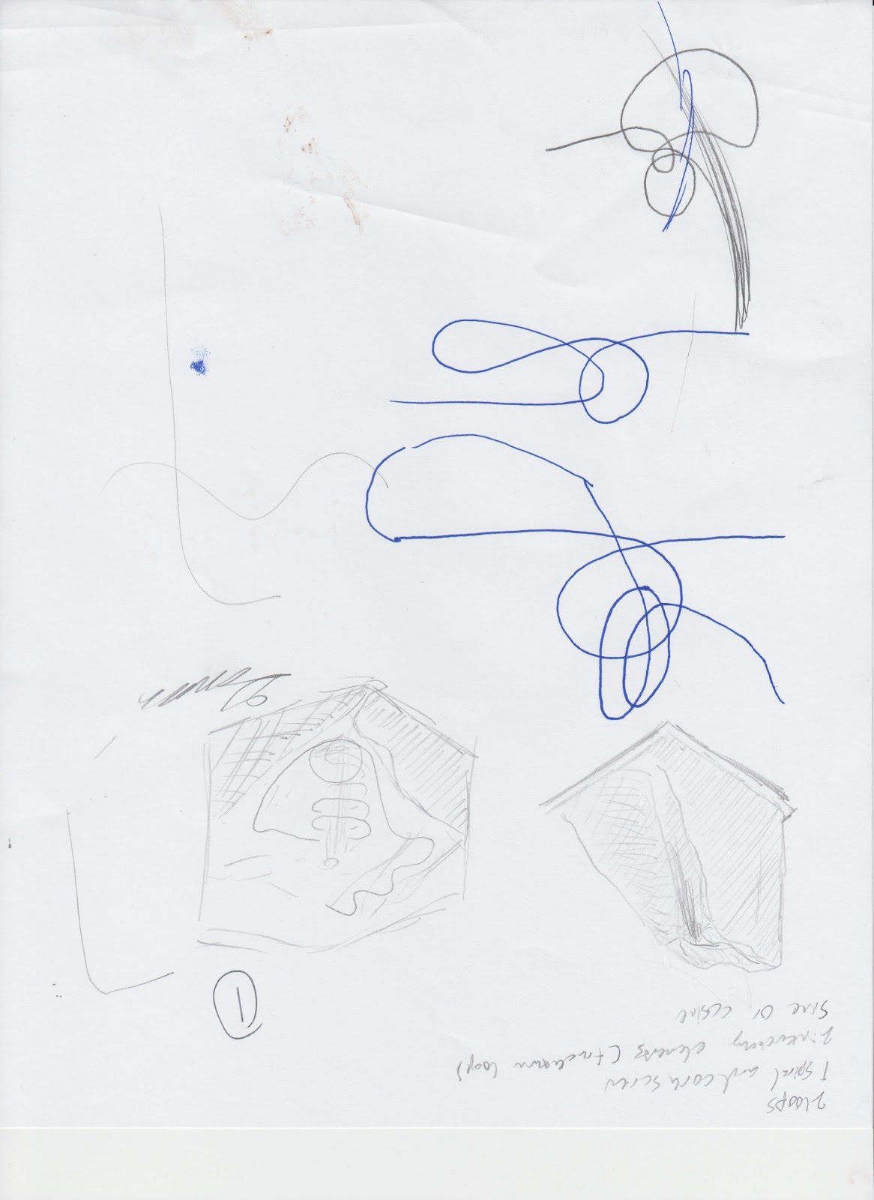

Figure : Potential Design 1

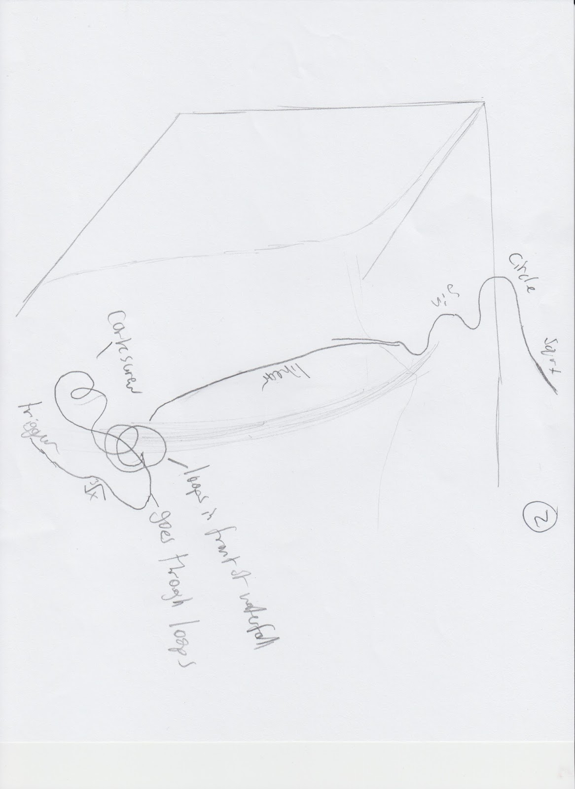

Figure : Potential Design 2

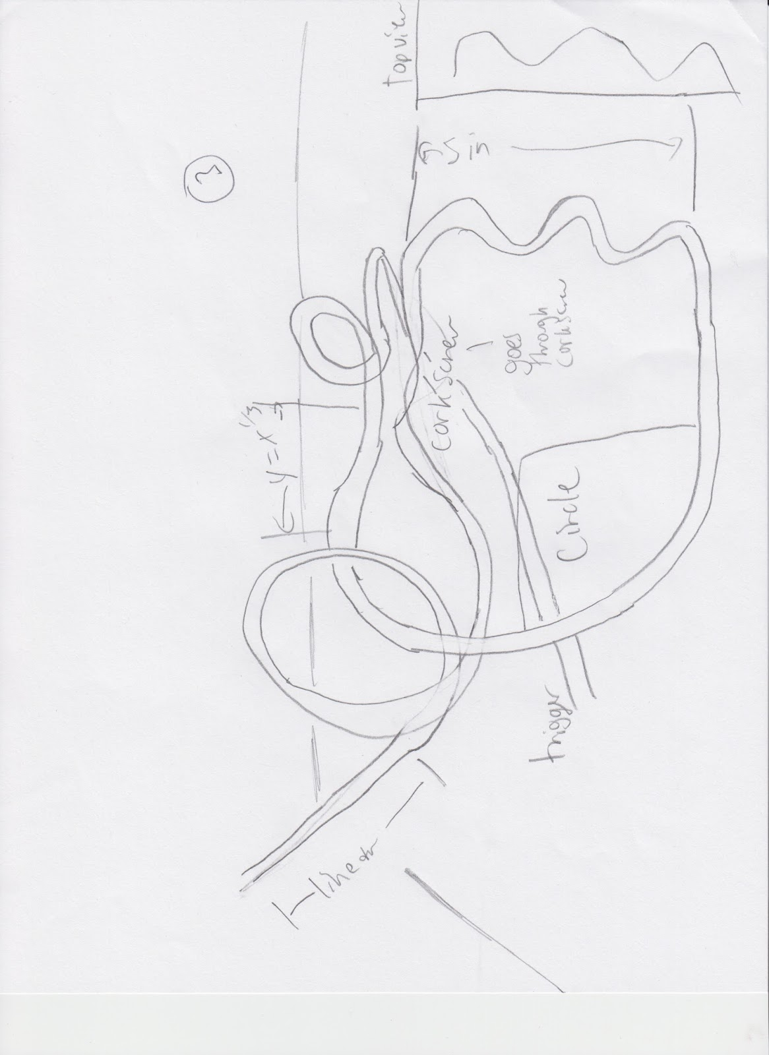

Figure : Potential Design 3

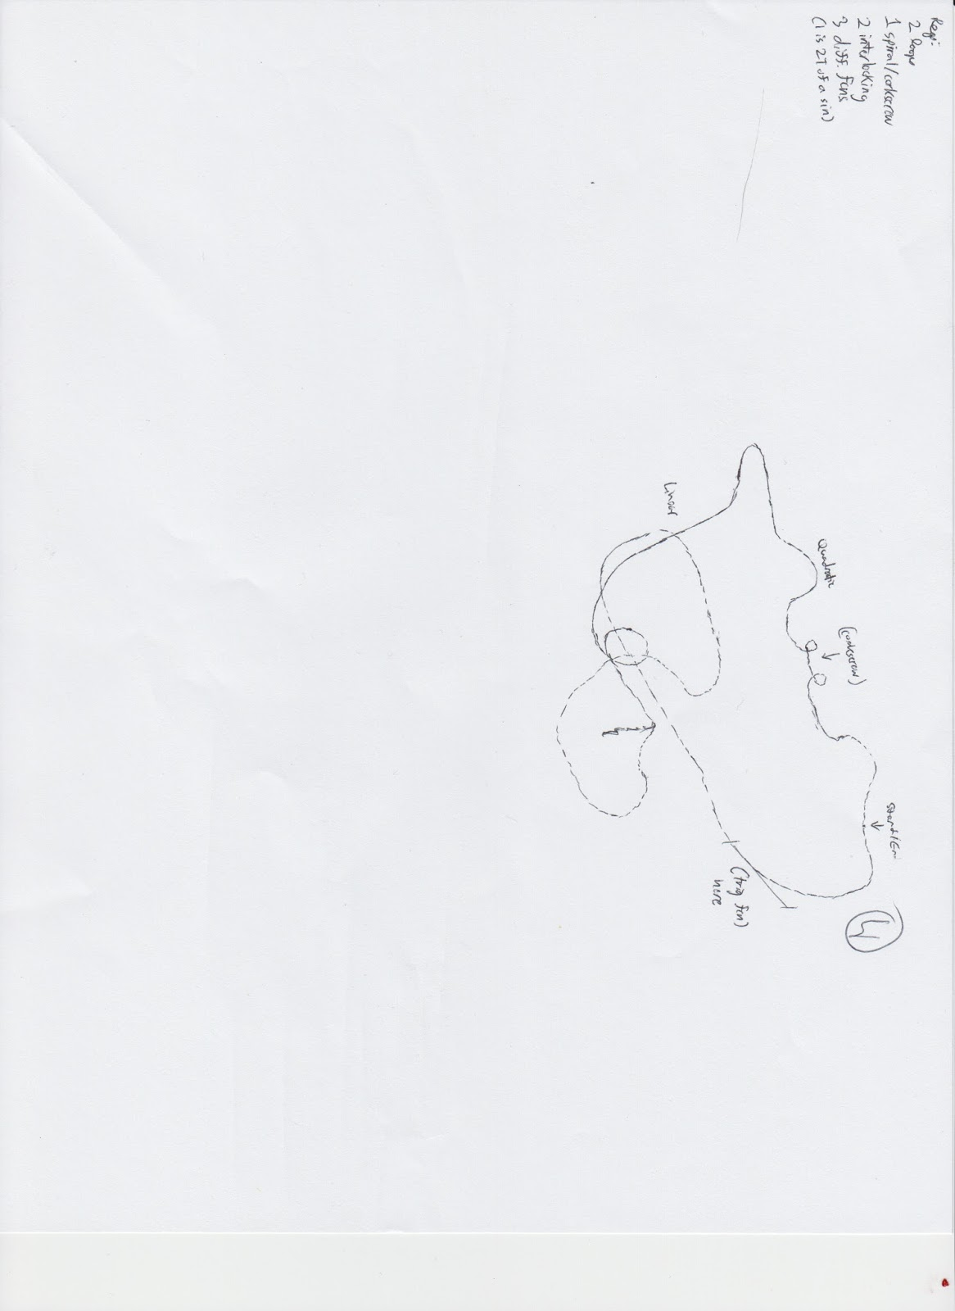

Figure : Potential Design 4

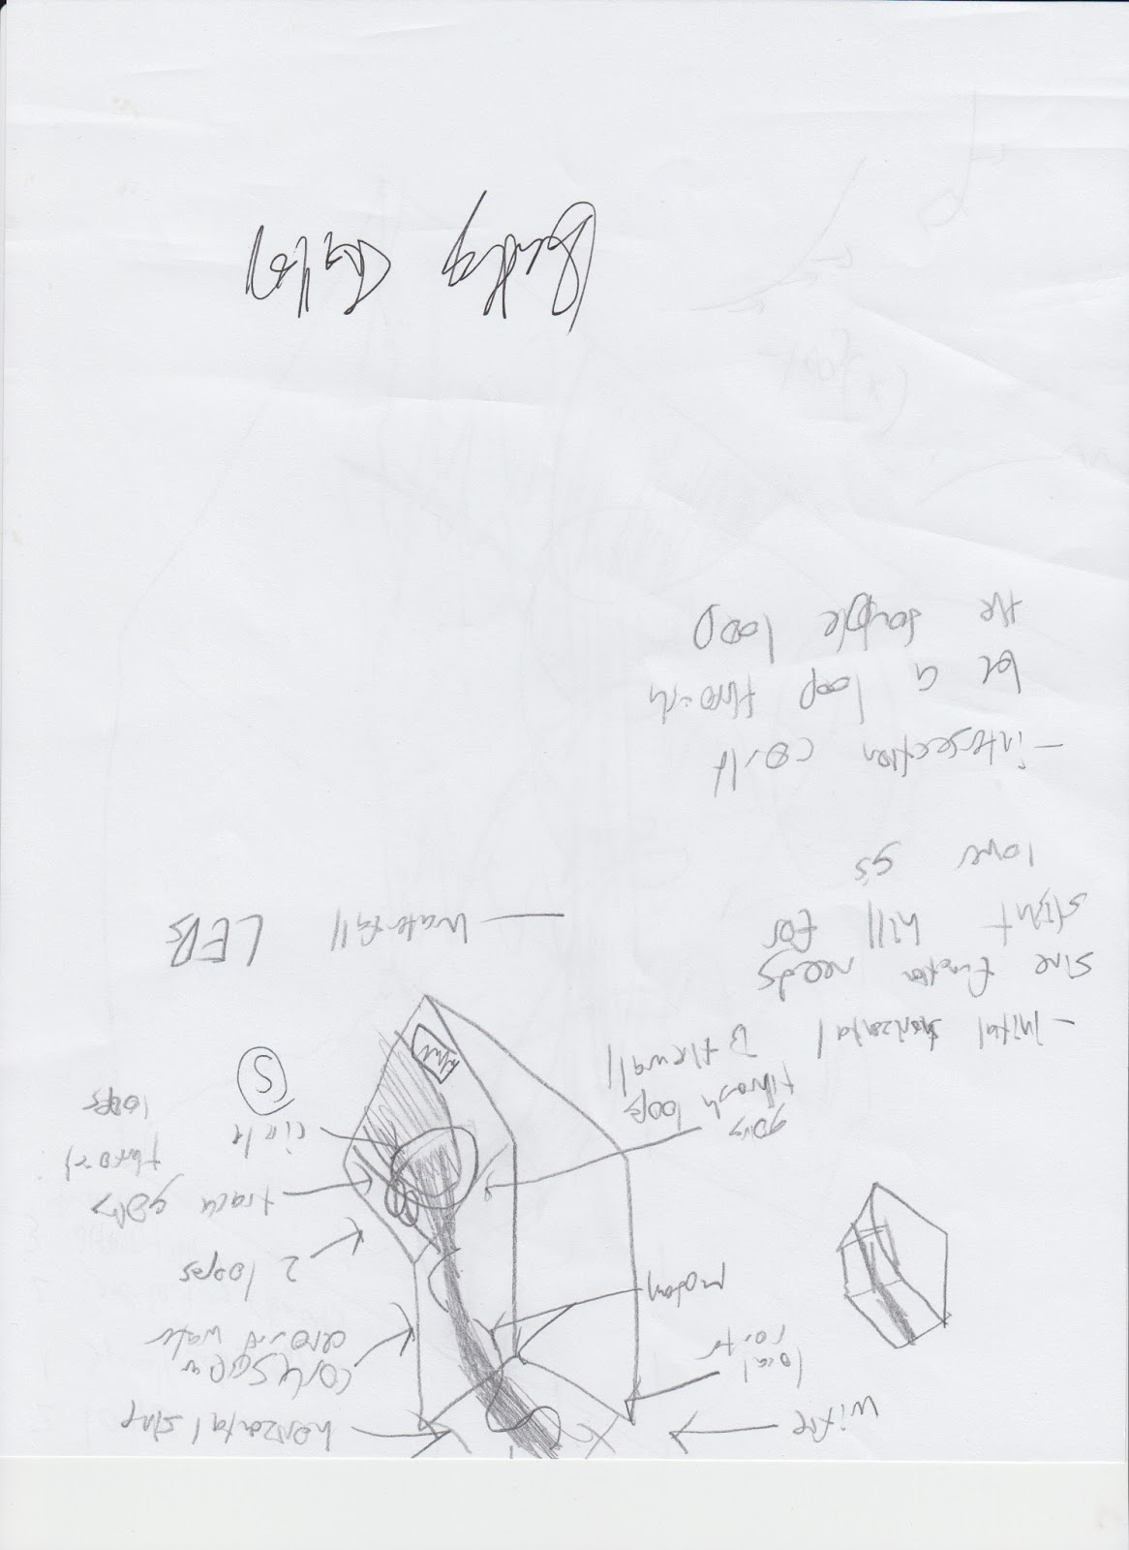

Figure : Potential Design 5

### 2.2.3 Selecting the Design

The possible designs were then put into a decision matrix.

Table : Design Decision Matrix Part 1

|  |  |  |  |  |
| --- | --- | --- | --- | --- |
| Idea | Enthusiasm | Feasability | Meets Requirements | Originality |
| 1 | 5 | 3 | 5 | 3 |
| 2 | 3 | 4 | 5 | 3 |
| 3 | 2 | 3 | 5 | 5 |
| 4 | 1 | 5 | 5 | 3 |
| 5 | 5 | 3 | 5 | 3 |

Table : Design Decision Matrix Part 2

|  |  |  |  |  |
| --- | --- | --- | --- | --- |
| Fun | Env. Impact | Optimized Area | Maximize v/a and jerk | Total |
| 5 | 2 | 5 | 5 | 33 |
| 5 | 3 | 1 | 5 | 29 |
| 4 | 3 | 1 | 5 | 28 |
| 3 | 4 | 1 | 5 | 27 |
| 5 | 2 | 4 | 5 | 32 |

The designs were judged on several categories to determine which one was the best solution. The first, enthusiasm, related to our personal enthusiasm of building the design. If we were not enthusiastic about the design, it would become more difficult to want to produce a quality product. Secondly, the designs were judged on feasibility to determine how likely it was that the model could be built of these designs. Next was the requirements. As each of the designs were not tested yet, the meeting of the requirements was all based off of estimations. The originality was based on how much the design did not look like the straightforward answer. This had nothing to do with simplicity. The greater the originality of a design, the greater the interest would be for both a rider and a builder. The next was how fun the design would be based on personal experiences of riding roller coasters. The seventh requirement was the environmental impact. Again, since this was estimates, it was entirely based on how much of the environment the roller coaster took up. This is similar to the next requirement about optimized area. The more compact the coaster, the better. The final criterion is that velocity, acceleration, and jerk are maximized. This was based on previous physics knowledge and intuition.

## 2.3 Detailed Design

### 2.3.1 Detailed Dimensions

The rollercoaster computer model takes up a rectangular prism with a length of 300 meters, a width of 261 meters, and a height of 172 meters.

The diameter of both loops is about 70 meters, with the center of the loops about 75 meters above sea level.

The length of the sine function is about 180 meters long, with an amplitude of about 30 meters.

The diameter of the spiral is 60 meters, with the spiral circling around three complete times.

The estimated length of track is 2701.49 meters.

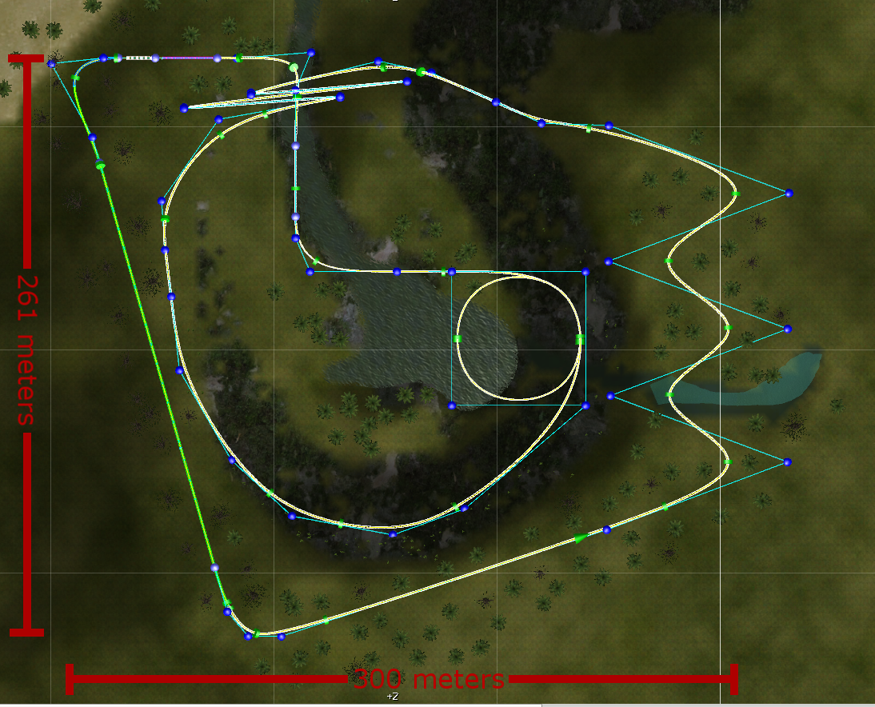

Figure : Roller Coaster Dimensions

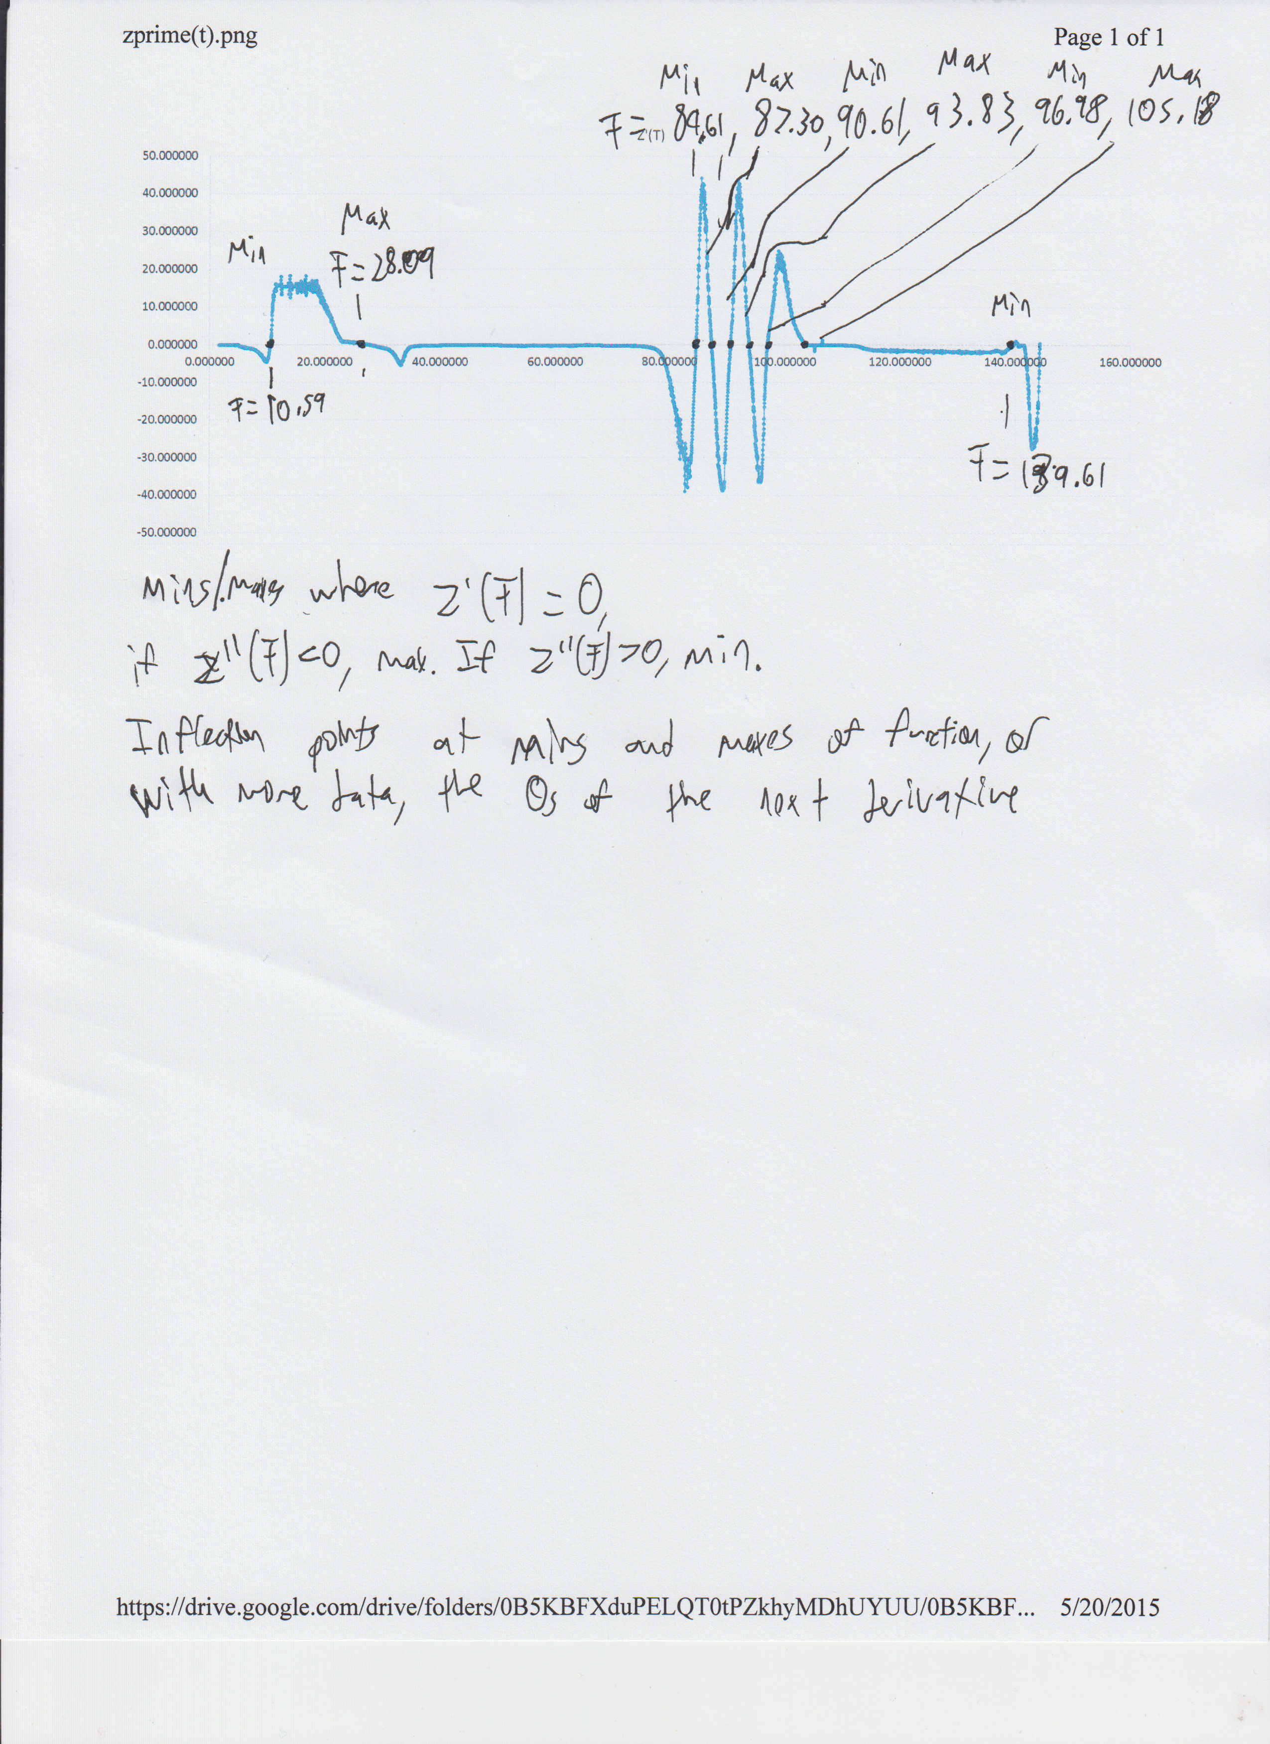

Figure : Mins/Maxes Along the Z-Axis

### 2.3.2 Bill of Materials

A sample build of materials was generated for a quick estimation of project costs for the marble roller coaster. Some of the materials had already been bought, or are available for use for free at the high school engineering lab which will greatly decrease costs. Equipment such as a soldering iron or heat gun are already owned by one or more of the team members. Prices are obtained through amazon, Home Depot, or their respective sources.

Table : Bill of Materials

|  |  |  |  |
| --- | --- | --- | --- |
| Name | Quantity | Price per | Sub Total |
| 48"x48" Plywood | 1 | $8.75 | $8.75 |
| Cabinet Handles | 4 | $1.78 | $7.12 |
| Marbles (24ct) | 3 | $5.25 | $15.75 |
| Wooden Coffee Stirrers (1000) | 1 | $5.60 | $5.60 |
| Coffee Straws/Stirrers (1000) | 1 | $5.05 | $5.05 |
| Soldering Iron | 1 | $93.37 | $93.37 |
| Heatgun | 1 | $34.99 | $34.99 |
| Wooden Dowels 1/2"x36" | 5 | $1.50 | $7.50 |
| Poultry Netting | 1 | $26.00 | $26.00 |
| Spray Paint | 1 | $4.99 | $4.99 |
|  |  | Total | $209.12 |

Some questionable items such as Poultry Netting is required, as they have some use in our project. Poultry Netting specifically will be used to create a frame for the topography model of the Island.

# 3. Business Case

## 3.1 Mission Statement

To educate the public about the process of data management.

### 3.1.1 Product

Pen Island Squad is preparing to create a rollercoaster dedicated to spreading knowledge of the Internet by focusing on the components of data management and transferring specifically focused on the transfer of a single internet package. This will make riders, likely regular Internet users, more aware of a utility that is becoming progressively apparent in daily life and how it works. This includes how easily data that is transferred may be corrupted, interfered with, as well as stolen.

### 3.1.2 Customers

The targeted audience is the typical upper-middle class household in the United States, with an estimated income of (at least) $128,000 and a minimum entertainment budget of $7,000 (or 5.4% of average household expenses). This market (estimated at nearly 17.4 million households or 14.1% of total households) may be tapped through a series of targeted national advertisements that center on the "novelty" of the Internet, as contrasted with the tropical environment.

## 3.2 The Case for Change

Given the rapid growth in the Costa Rican tourism industry (aided in no small part by the opening of Jurassic Park on the Isla del Nublar), the Pen Island Squad believes that there is an unprecedented opportunity for economic development on the nearby Isla del Nublar.  Currently, the Isla del Coco is designated as both a national park by the Costa Rican government and a World Heritage Site by the United Nations Educational, Scientific and Cultural Organization (UNESCO).  However, the current government has expressed a desire to develop an educational theme park on the Isla del Coco in order to tap into the burgeoning tourism industry and to promote the development of STEM (Science, Technology, Engineering, and Mathematics) skills among the general populace and potential tourists.

Yet a major concern of the Costa Rican government (as well as UNESCO) is the risk of massive environmental alteration and/or devastation as a byproduct of development. It must be stated that all large economic projects have the potential for environmental and ecological hazards, given the rather extensive processes used in construction and the often unknown or unpredicted effects of development on natural processes in the affected areas. Nevertheless, the Pen Island Squad is confident in its ability to safely minimize the risk of contamination or other potentially-damaging hazards while fulfilling the educational and economic goals of the Costa Rican government and guaranteeing a sufficiently-profitable rate of return for any potential shareholders.

## 3.3 Scope

The Pen Island Squad’s purpose in building a roller coaster on the Isla del Coco is simple and straightforward: to provide the public with a means of entertainment that provides significant educational value and maintains the local environment’s integrity.  With regards to this particular design, the Pen Island Squad believes that the centrality of the Internet to contemporary popular culture provides a tremendous opportunity to increase awareness about digital innovation and provide technological context to this (relatively) recent cultural phenomenon.  Given the significant size and purchasing power of the target population (See Advertising Campaign Section), the Pen Island Squad believes that there is significant demand for a roller coaster thematically designed around the technological (software) components of the Internet.

This roller coaster will have international appeal, and is relevant to all market. STEM is a universal subject, not limited by language, and the principles and engineering concepts used and explained in the Pen Island Squad’s coaster. Educational institutions around the world can take use in this, without limits. Everyone will be interested, everyone will appreciate, and everyone will want to ride.

## 3.4 Project Implementation

### 3.4.1 External Communications and Stakeholders

In order to coordinate and harmonize relations with external stakeholders (government agencies, non-governmental officials, environmental groups, etc), the Pen Island Squad plans to initiate a public relations campaign to reassure the public of the economic benefits (jobs, private investment, tourism, etc) of the project and alleviate any potential concerns.  The company will also ensure transparency by regularly released internal memos and other documents fundamental to the company’s official policy.  We will maintain close relations with government agencies and non-government organizations (primarily UNESCO) through regularly-scheduled meetings and updates, and all the potential ecological impacts of the project will be thoroughly analyzed and documented by third-party inspectors and regularly released to environmental advocacy groups.

### 3.4.2 Advertising Campaign

For the American advertising campaign, the Pen Island Squad hope to attract affluent tourists interested in visiting exotic tropical locales while retaining the benefits and “style” of the “First World.”  The targeted audience is the typical upper-middle class household in the United States, with an estimated income of (at least) $128,000 and a minimum entertainment budget of $7,000 (or 5.4% of average household expenses).  This market (estimated at nearly 17.4 million households or 14.1% of total households) may be tapped through a series of targeted national advertisements that center on the "novelty" of the Internet, as contrasted with the tropical environment.

This market has money to spend, but nothing worthwhile to spend it on.  With growing challenges to their social status via widening social and economic gaps and the specter of international conflict, what they value most is the distant memories of social and economic stability.  We remind them of the “carefree days” of yesteryear through our advertisements; we showcase our roller coaster as a palate-cleanser, something that makes you forget about the world and just enjoy the moment.  The lights, the fresh air, the whirring of the air; it’s almost relaxing.  We will prioritize visual aids (primarily television and online advertisements) that will amplify this sensation and attract the customer base.  This roller coaster is almost like a spa, but for the adventurer.

Assumptions:

Share of “typical” household budget devoted to entertainment: 5.4%

Minimum expense of travel and/or stay: ~$7,000

Minimum household income: $127,951

## 3.5 Legal Policy

The Costa Rican government has officially granted the Isla del Coco to the Pen Island Squad; as such, the company does not have to purchase the land or pay royalties for land use. All other expenses, such as labor, building materials, etc, will be funded via a 50-50 joint venture between General Electric and Google Inc.

## 3.6 Financial Appraisal

### 3.6.1 Costs Analysis

### 3.6.1.1 Construction Cost Analysis

Given the disparity in lengths and costs for wooden roller coasters, averages from six notable wooden roller coasters were taken and adjusted for metric measurements.  Monetary values have been adjusted for inflation to 2015 USD.

Table : Construction Costs

|  |  |  |  |
| --- | --- | --- | --- |
| Name | Aggregate Cost ($) | Total Length (m) | Average Cost ($/m) |
| Psyclone | $8,616,814 | 1,012 | $8,514.64 |
| Colossus | $21,600,184 | 1,218 | $17,734.14 |
| Apocalypse | $10,940,863 | 884 | $12,376.54 |
| Lightning Racer | $17,174,724 | 1,034 | $16,609.98 |
| Beast | $13,035,758 | 2,243 | $5,811.75 |
| Boulder Dash | $8,243,868 | 1,440 | $5,724.91 |
|  |  |  |  |
| Subtotal | $79,612,211 | 7,831 | $60,997.74 |
|  |  |  |  |
| Average | $13,268,702 | 1,305 | $10,166.29 |

Construction cost differential (CR to US) -56100

Average cost/meter (CR) = (Cost differential)*[(Aggregate Cost Subtotal)/(Total Length Subtotal)]

Average cost/meter (CR) = (56100)*[$79,612,211/7,831m]

Average cost/meter (CR) - $5,693.12/m

Total length of roller coaster - 2,701.5m

Aggregate cost of roller coaster = (Average cost/meter)*(Total length)

Aggregate cost of roller coaster = ($5,693.12/m)*(2,701.5m)

Aggregate cost of roller coaster (CR) - $15,379,964

Assumptions:

GDP/hr - $17.81/hr

Avg wage (CR construction laborer) - $13.89/hr

Avg wage (project) - $17.00/hr

### 3.6.2    Revenue Analysis

### 3.6.2.1 Comparative Revenue Analysis

Given the disparities in rider capacity and consumer costs for wooden roller coasters at various amusement parks, averages were taken from six roller coasters and adjusted on a per-hourly basis.

Table : Coaster Revenue Statistics

|  |  |  |  |  |  |  |
| --- | --- | --- | --- | --- | --- | --- |
| Name | Max. Ride Capacity (riders) | Max. Hourly Capacity (riders/hr) | Cost per Passenger ($) | Duration (min) | Average Revenue per Hour ($/hr) | Annual Revenue ($) |
| Psyclone | 24 | 1,200 | $72.99 | 1:50 | $70,070.40 | $145,746,432 |
| Colossus | 24 | 2,600 | $72.99 | 2:30 | $151,819.20 | $315,783,936 |
| Apocalypse | 22 | 1,000 | $72.99 | 3:00 | $58,392 | $121,455,360 |
| Lightning Racer | 24 | 1,300 | $61.95 | 2:20 | $64,428 | $131,433,120 |
| Beast | 36 | 1,200 | $61.99 | 4:10 | $59,510.40 | $123,781,632 |
| Boulder Dash | 24 | 1,800 | $40.99 | 2:30 | $59,025.60 | $122,773,248 |
|  |  |  |  |  |  |  |
| Subtotal | 154 | 9,100 | $383.90 | 16:20 | $463,245.60 | $960,973,728 |
|  |  |  |  |  |  |  |
| Average | 26 | 1,517 | $63.98 | 2:43 | $77,207.60 | $160,162,288 |

Assumptions:

Average capacity - 80%

Operation time (annual) - 2,080 hrs

### 3.6.2.2 Revenue Projections

Number of trains - 2 trains

Capacity of train - 26 passengers

Max. ride capacity = (Num. of trains)*(Capacity)

Max. ride capacity = (2 trains)*(26 passengers)

Max. ride capacity = 52 passengers

Duration of ride - 2:38

Total boarding time - 15:00

Max. hourly capacity = (Max. ride capacity) *(Num. of min) - (Total boarding time)Duration of ride

Max. hourly capacity = (52 passengers)*(60:00) - (15:00)2:38

Max hourly capacity = 938 passengers

Operation time (annual) - 2,080 hrs

Annual ridership = (Max. hourly capacity)*(Operation time)

Annual ridership = (889 passengers)*(2,080 hrs)

Annual ridership = 1,848,304 passengers

Charge per passenger - $59.99

Total annual revenue = (Charge per passenger)*(Annual ridership)

Total annual revenue = ($59.99)*(1,848,304 passengers)

Total annual revenue = $110,879,745

## 3.7 Economic Appraisal

Benefits

* Increase in foreign direct investment
* Expansion of tourism industry (hotels, travel accommodations, etc)
* Increased employment in construction and tourism industries
* Increased international recognition; easier access to foreign capital
* Sustained increase in GDP growth

Costs

* Marginal decline in ecological tourism due to displacement
* Reduction in capital stock (limits investment opportunities and government borrowing)
* Risk of endangering endemic species
* Risk of endangering local flora (possible reduction in biomedical research)
* Risk of shrinking gene pool (limits genetic raw material for biotechnological innovation)

# 4. Ecological Impact

## 4.1 Executive Summary

Given the Isla del Coco’s status as a World Heritage Site, any proposal for development involving the island must pay extraordinary attention to the fragile ecology of the island. According to the United Nations Education, Science and Cultural Office (UNESCO), the Isla del Coco has little in the way of biodiversity among flora and fauna, yet possesses a large number of endemic species. This complicates the task of minimizing the ecological impact, as special care must be taken to avoid endangering the fragile habitats of these species (which, quite literally, have no other home). In order to ensure the ecological integrity of this proposal, the Pen Island Squad has commissioned the following environmental report to evaluate all potential environmental concerns and potential measures that will resolve said concerns.

According to this report’s findings, there are considerable ecological risks attached to this endeavor. Among the numerous threats to the local environment, the most pernicious are the displacement of flora and fauna due to construction and the contamination of the island’s waterfall and its immediate coastal area from chemicals during the construction process. Nevertheless, the presence of mitigation mechanisms will assuredly minimize any potential impacts of this project. Overall, this proposal will have a minimal impact on the Isla del Coco’s ecology, highlighting the compatibility of commercial development and concerns regarding environmental sustainability and integrity.

## 4.2 Analysis

Potential ecological effects (and possible solutions) of the current roller coaster project include, but are not limited to:

*Displacement of local flora and fauna at the island's waterfall due to clearing of area and construction of roller coaster and auxiliary structures.*

Construction surrounding the area will be minimized in terms of damage to local terrain, with minimal uprooting of the local flora. The river/waterfall itself will not be affected nor touched during construction or operation.

*Presence and/or transport of hazardous chemicals downstream via runoff, originating from building materials used in construction phase.*

The only hazardous chemicals involved during the development process derive from the concrete used in building foundations for wooden supports, which will be restricted to the immediate soil surrounding the supports, and treated wood, which will have already been sealed and polished, preventing leaking of chemicals into the river and subsequently the ocean.

*Contamination of surrounding rain forest from chemicals involved in treatment of wood.*

The wood will be sealed and polished before transport to the island, and it will be covered with a protective layer of primer and long-lasting, rain resistant paint.

*Introduction of invasive microbiological species to local environment.  May result in significant alterations in ecological web and infection of local species with parasitic microorganisms.*

The equipment brought to the island to construct the terrain is hygienic, and repeatedly scrubbed after each use to prevent microbes or other parasitic organisms from infecting this environment.

*Disruption of migratory patterns for avian and fish species along waterfall (and throughout island) due to clearing of surrounding rain forest.*

Neither the waterfall nor the river will be disrupted nor affected in anyway, and the surrounding trees will only be affected if they interfere with the support structures or imperil rider safety.

*Threatening, endangering, and/or extinction of endemic species due to clearing of traditional habitats and alteration of ecological relations (food web).*

A small area is being developed, with the impact on the land minimized, and our coaster is specifically designed to work with the land.  Other than the removal of a few birds’ nests as trees are taken down, few animals will be affected, and there will be no widespread impact on native species.

## 4.3 Potentially Affected Species

It is an unavoidable fact that certain species are more susceptible to human encroachment than others. This report will cover three endangered species from each ecological category (i.e flora and fauna) and explicate their vulnerability.  The species affected by this proposal include, but are not limited to:

### 4.3.1 *Flora*

1. *Caesalpinea bonduc* - Also known as the “gray nicker bean,” *Caesalpinea bonduc* is a tropical shrub often found along large bodies of water, particularly beaches, and around trees. It is currently being researched for potential pharmaceutical uses, including treatment for microbial infection, parasitic nematodes, and Type 2 diabetes.  Local population may be adversely impacted by clearing process surrounding waterfall, as trees must be cut down in order to secure a construction site. Ecological impacts may be mitigated via “bio-recycling”; careful extraction and donation of live specimens for scientific research.

2. *Hibiscus tilliaceus* - Commonly referred to as the “green cottonwood,” *Hibiscus tilliaceus* is a large tropical shrub known to form impenetrable thickets.  May be adversely affected by clearing process, as chemicals used in construction process may contaminate the runoff and poison organisms downstream.  Planned deforestation of surrounding area may also devastate local population, given its proclivity to concentrate in tropical forests.

3*. Cocos nucifera* - Known primarily as the “coconut palm,” *Cocos nucifera* is a medium-sized tropical tree (with a maximum height of 29 m) popularized by its eponymous fruit (coconuts).  Heavily concentrated in the coastal tropics, especially in the specific.  Is grown commercially for its coconuts as well as its “coconut water,” and coconut oil has been proven to reduce the risk of heart disease.  Given the project’s geographical proximity to the beach, the local population may face adverse impacts including deforestation, which will (in turn) affect any organisms inhabiting the trees.  Minimizing deforestation through precise optimization of land use will be essential to reducing the negative impacts of development on the local population.

### 4.3.2 *Fauna*

1. *Anous stolidus* - Also known as the “Brown noddy,” *Anous stolidus* is a medium-sized seabird (maximum length and wingspan of about 45 cm and 86 cm) usually habituated in tropical and subtropical locales.  Each breeding pair lays a single egg each year in trees, shrubs, and even man-made structures.  May be adversely affected by clearing process, where natural habitats are bulldozed and/or felled to clear land for construction.  May also build nests within construction zone, thereby endangering the safety of workers.  Potential impact may be mitigated through use of bird nets around main/auxiliary structures and around construction zone proper.

2. *Sula leucogaster* - Also known as the “Brown booby,” *Sula leucogaster* is a large-sized seabird (maximum length and wingspan of 75 cm and 150 cm, respectively) that inhabit both tropical islands and mainland coasts.  Breeding pairs lay 1-3 eggs at a time. They tend to nest on the ground, yet also use man-made structures and vegetation for shelter.  May be adversely affected by construction process and clearing of breeding areas, as well as posing a safety hazard by nesting within construction zone.  Impact on local population may be mitigated by installation of bird nets around construction zone and alongside main/auxiliary buildings in addition to scaffolding.

3. *Eretmochelys imbricata* - Also known as the “Hawksbill turtle,” *Eretmochelys imbricata* is a medium-sized sea turtle (adults measure up to 91 cm) known to inhabit the beachfronts of tropical regions.  Extensively migratory.  Currently listed as “endangered” due to human exploitation for valuable shell.  May be significantly affected by chemical runoff and/or general construction process.  Effects may be mitigated by fencing-in the construction zone and using filtration nets to mitigate contamination.

## 4.4 Mitigation Policy

Due to the large presence of endemic species on the Isla del Coco, mitigation must be prioritized in order to reduce the potential impact of our proposal on the ecological integrity of the island.  We have already explained how our proposal’s impact on the island will be minimized in the Analysis section, so what follows is a simple summary of our planned mitigation measures:

* Optimizing area for development to minimize displacement and maximize efficiency (reduce sprawl).
* Treat wood before transporting it to island.
* Sterilize equipment, run health checks of workers, ensure rigorous vaccination protocols, including specifically tetanus and malaria.
* Find ecologically-friendly alternatives to toxic/hazardous chemicals used in construction.
* Locate and identify habitats of endemic and/or rare species; avoid areas where endemic/rare species are densely concentrated.
* Utilize an isolated renewable power source to power the roller coaster

# 5. Physics Analysis

## 5.1 Rectilinear Motion Calculations

We were able to log certain data from a simulation of riding the model, taking the (x,y,z) coordinate of the cart every 10ms, along with the engine’s calculated velocity, acceleration, and jerk. We checked these numbers by calculating the theoretical velocity, acceleration, and jerk at every point, but didn’t have enough accuracy to show the actual acceleration or jerk at every point.

Through breaking the model down into 3 separate axes as defined by EN 13814 5.2.1.1, we then produced 3 separate functions showing x, y, and z each as functions of time.

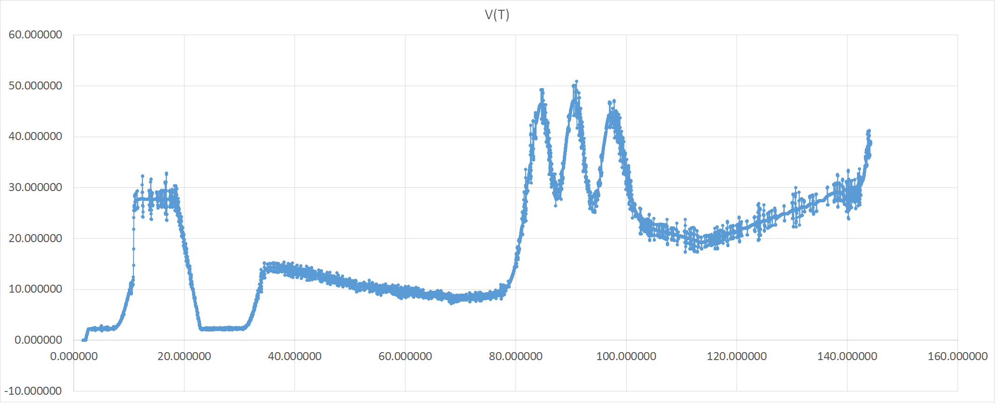

Figure : Horizontal X position (m) at time t

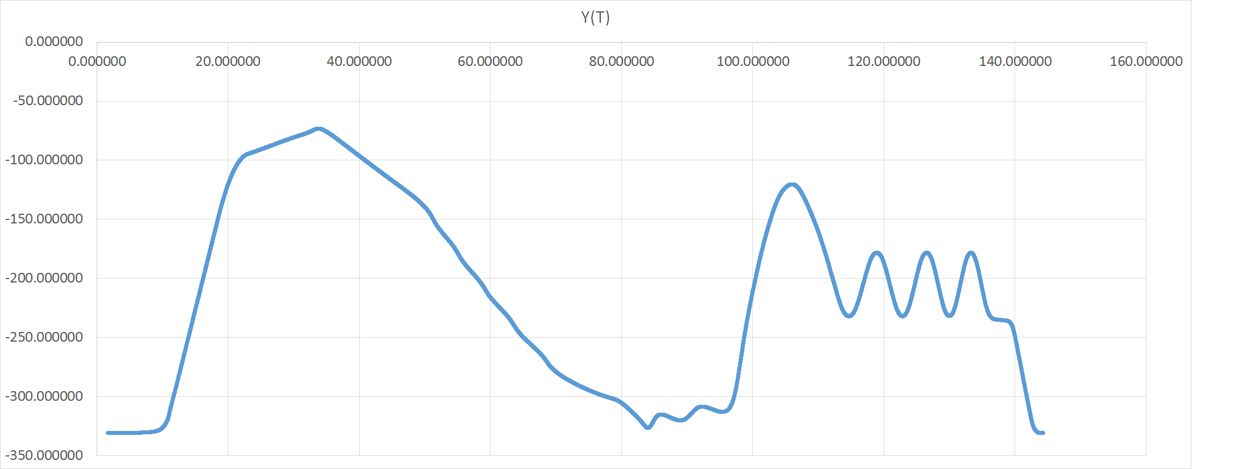

Figure : Horizontal Y position (m) at time t

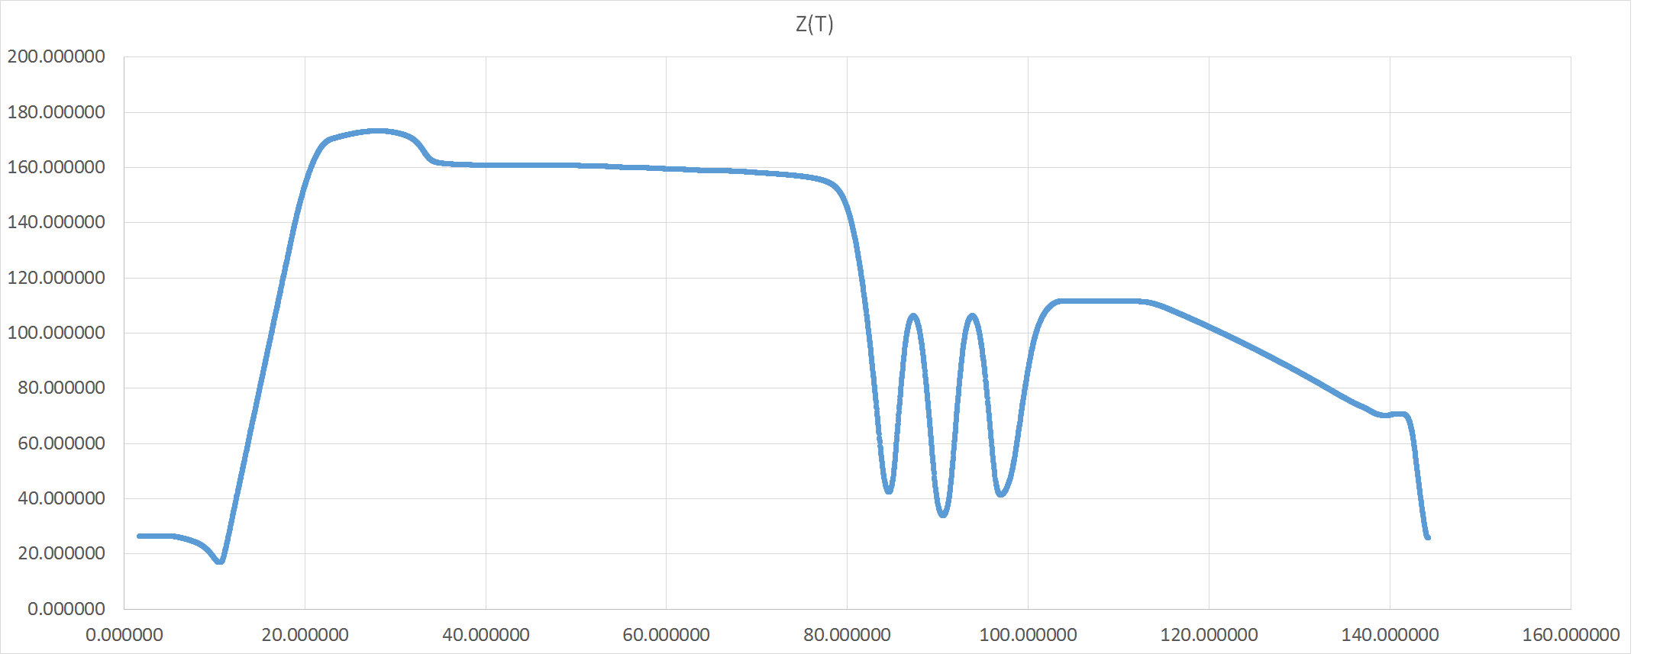

Figure : Vertical Z position (m) at time t

These graphs were very in sync with the model and our design, showing the position at any point, allowing the entire model to be plotted and recreated from this information alone.

We also graphed height Z as a function of position X along with position Y, effectively giving us perfect side views of the model.

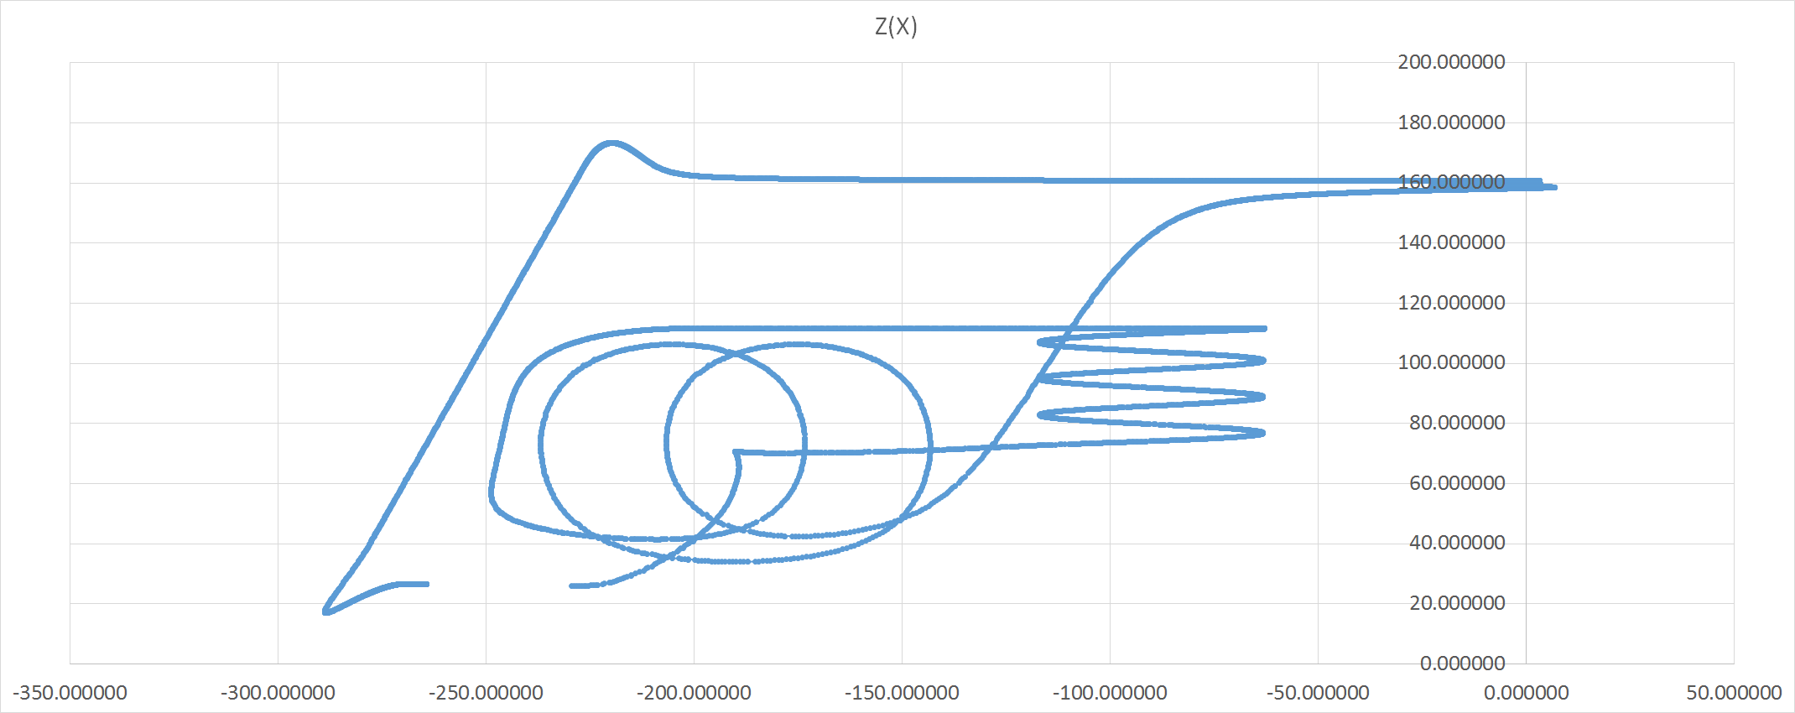

Figure : Vertical X position (m) at position Y

Our final visual representation of the model and its position, was a graph of position Y as a function of position X, effectively giving us a “top-down” view on the roller coaster.

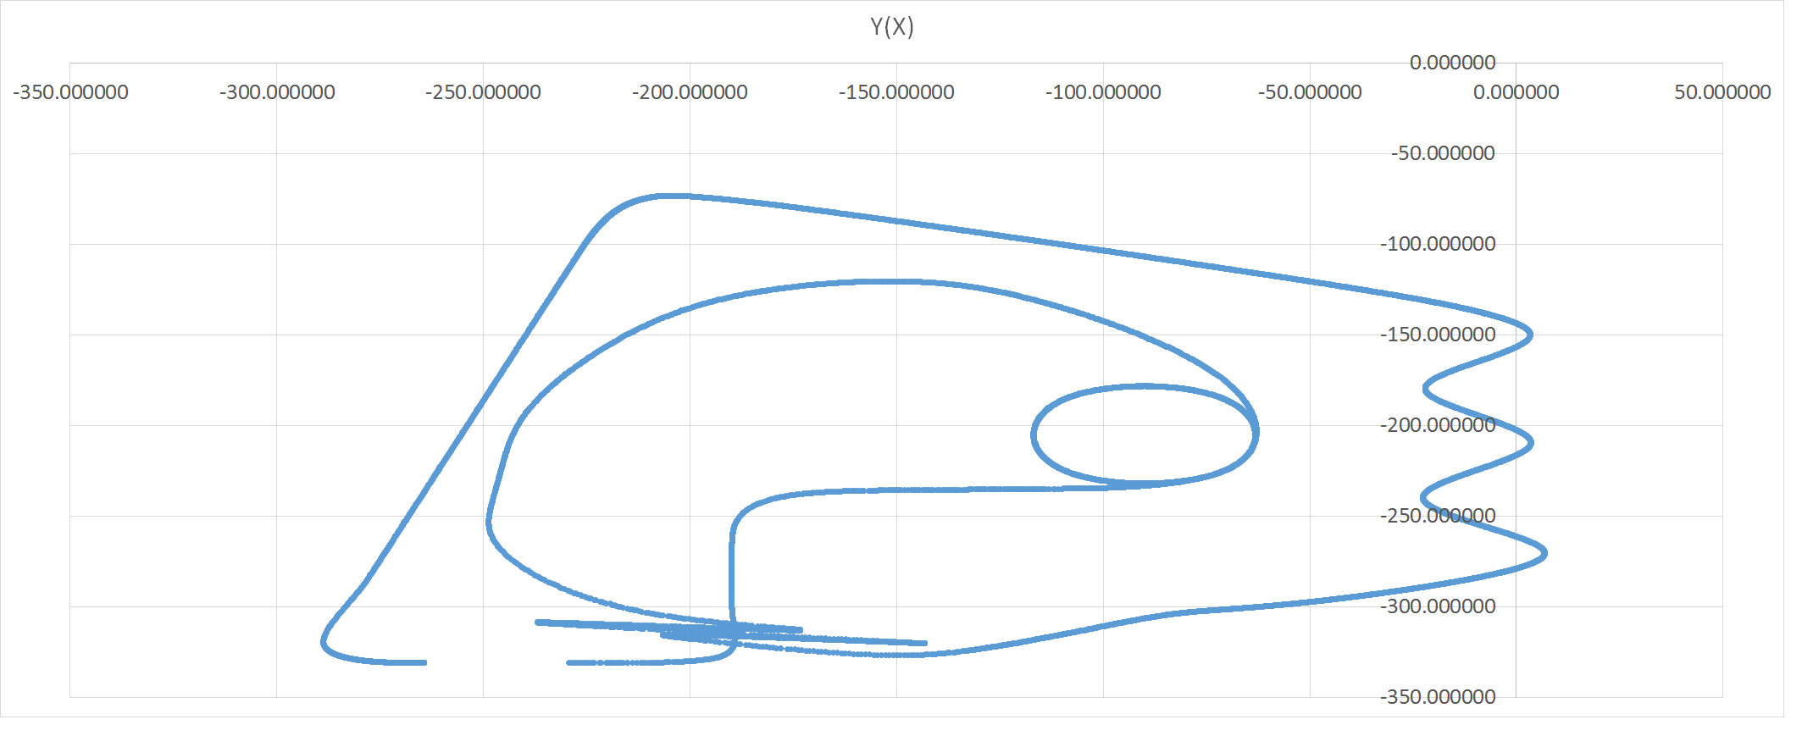

Figure : Horizontal Y position (m) at position X

This information was very consistent with our simulated model, with the top down and side views looking nearly identical to the model, so we calculated the velocity along each cardinal axis, which was something the simulation did not give us.

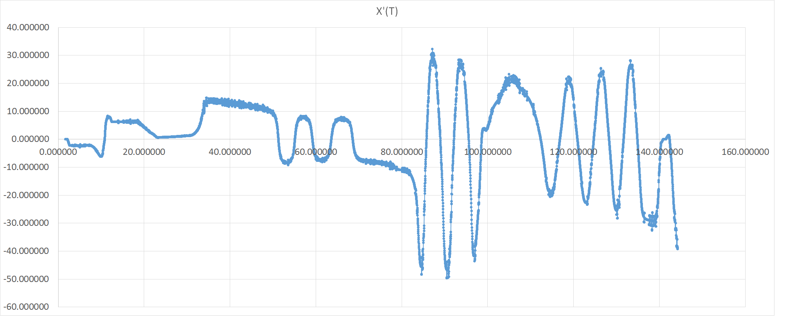

Figure : Horizontal X Velocity (m/s) at time t

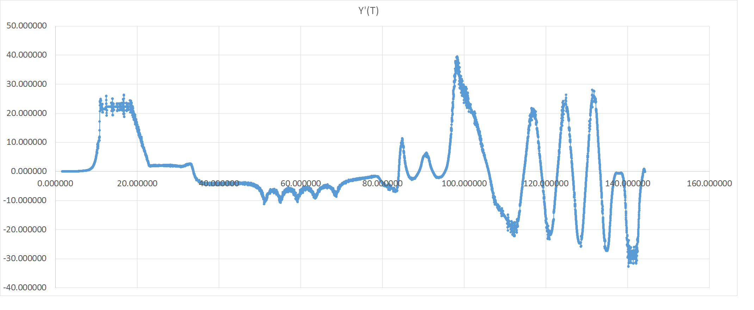

Figure : Horizontal Y velocity (m/s) at time t

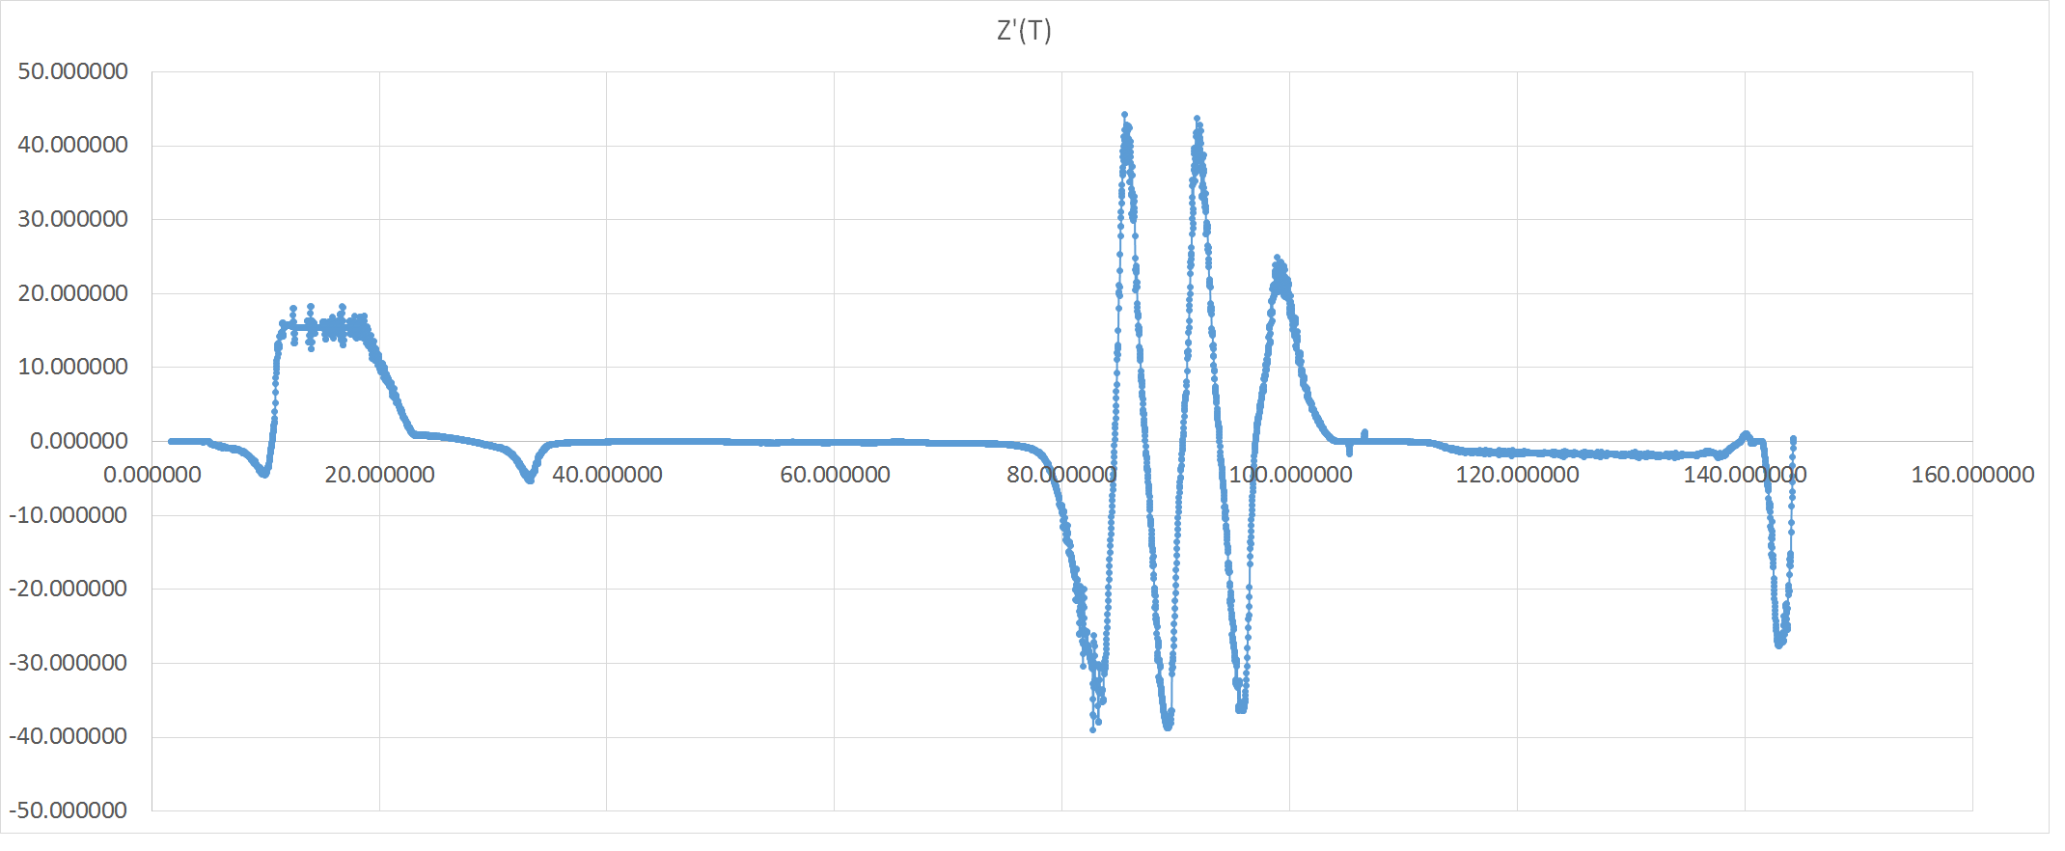

Figure : Vertical Z velocity (m/s) at time t



Figure : Velocity (m/s) at time t

At this point, our coordinate points were not accurate enough to calculate the acceleration of the cart along each cardinal axis, but the simulation does provide horizontal and vertical G-forces.

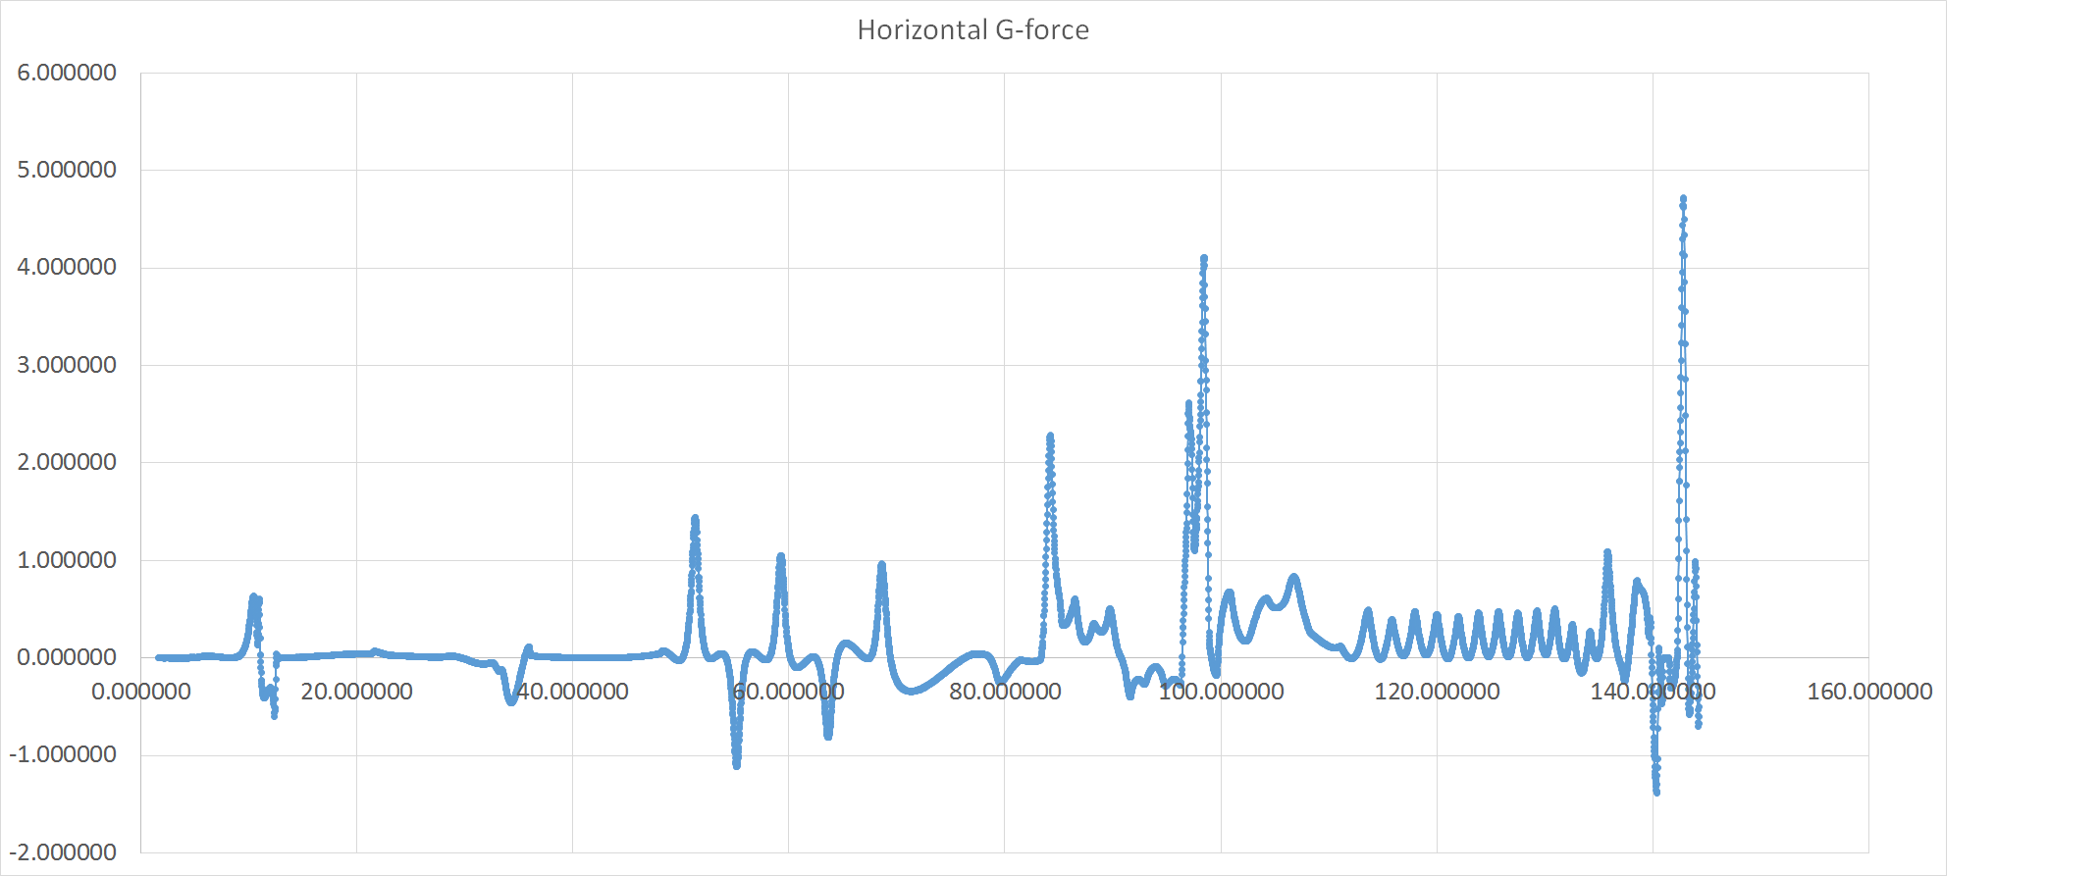

Figure : Horizontal G-force at time t

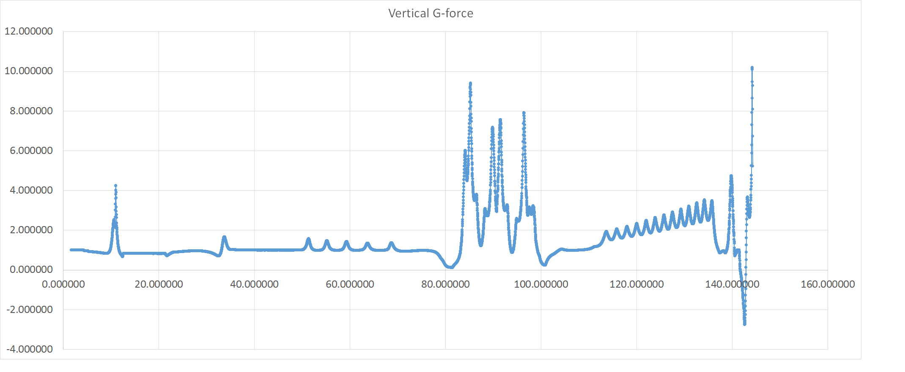

Figure : Vertical G-force at time t

## 5.2 Energy Calculations

Below are the graphs of the different types of energies throughout the ride of the coaster.

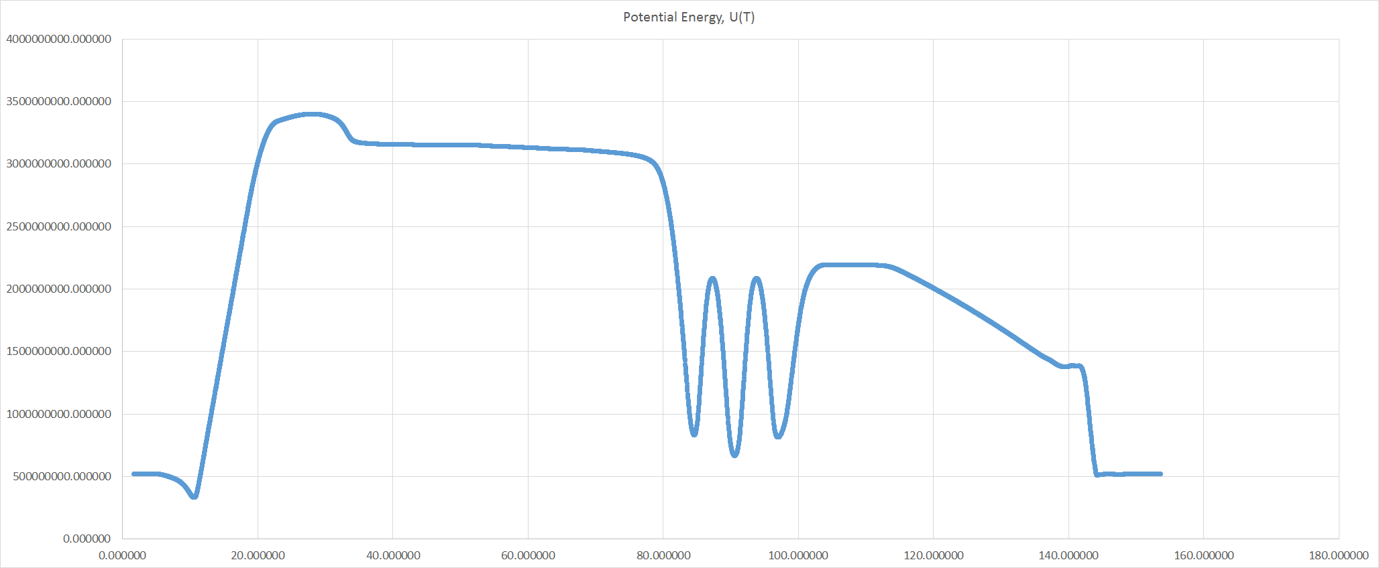

Figure : Potential Energy vs. Time

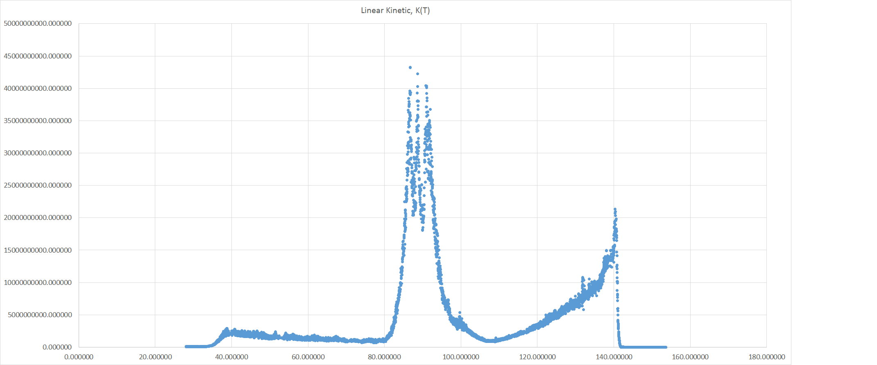

Figure : Linear Kinetic Energy vs. Time

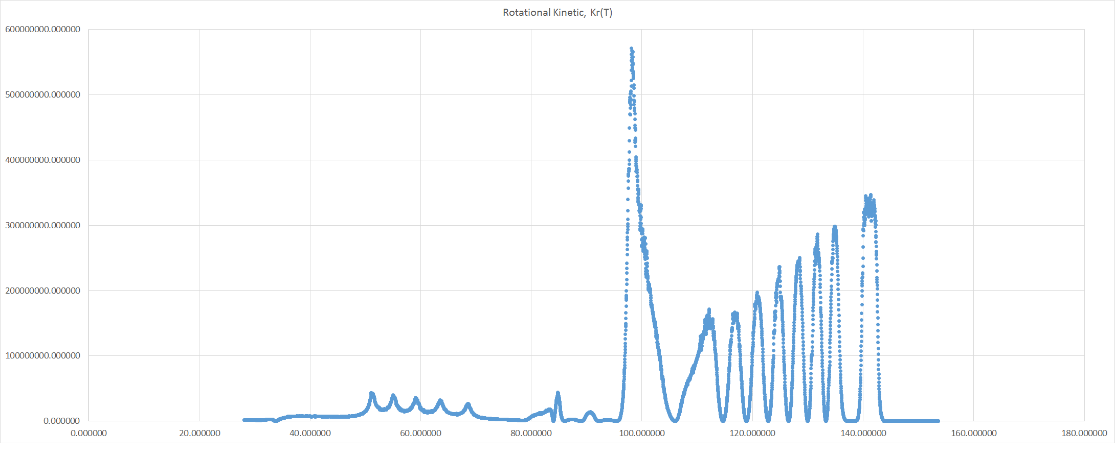

Figure : Rotational Kenetic Energy vs. Time

## 5.3 Free Body Diagrams

Of all the locations on the coaster, the top of the loops are the most critical points. If the marble successfully completes the top of the loop, the entire coaster will work flawlessly. The key is the marble’s velocity as there are no upward forces to keep the marble on the track as evidenced by the free-body diagram.

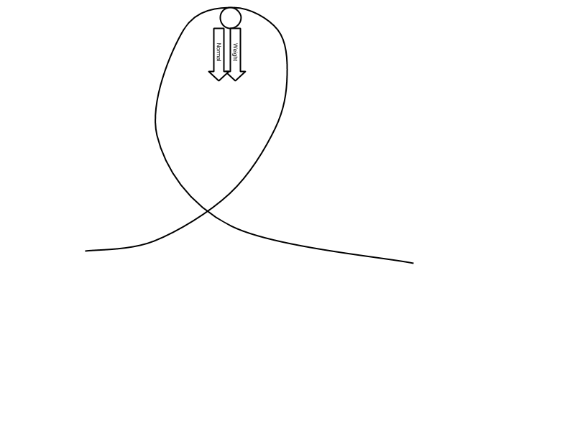

Figure : Free Body Diagram Top of the Loop

This implies that the centripetal force is, as by definition, inwards. However, a different story occurs at the sides of the loops as now the normal force and the weight go in different directions. The weight still slows down the marble but the normal force still pushes the marble around the loop.

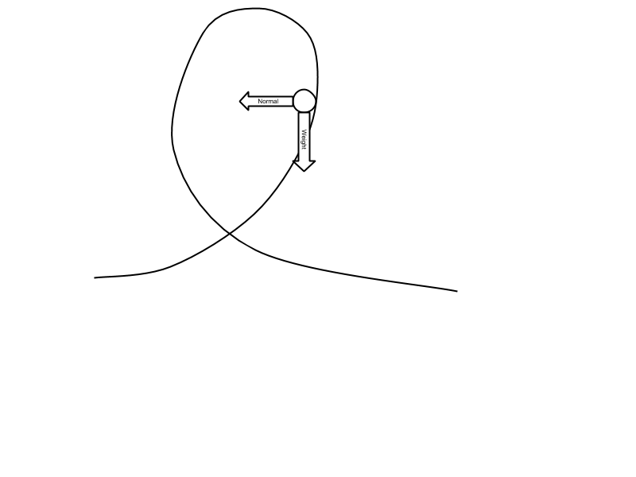

Figure : Free Body Diagram Entrance of the Loop

However, going out of the loop, the opposite happens to the speed. The marble speeds up because of its weight. With that said, the marble still moves around the loop due to the normal force.

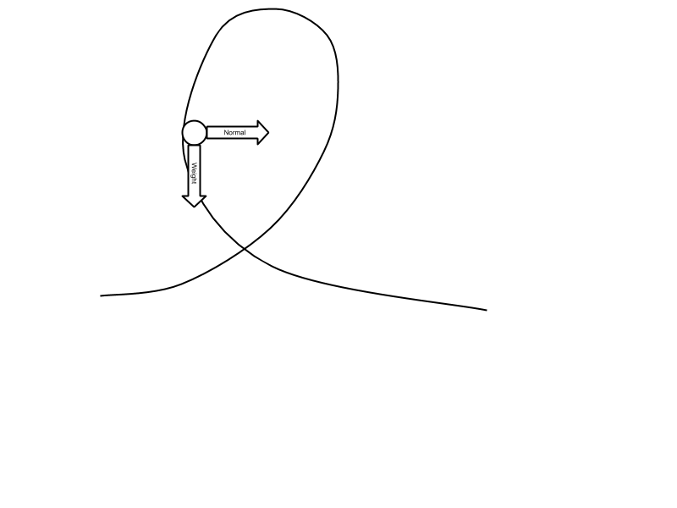

Figure : Free Body Diagram Exiting the Loop

Also, when the marble goes down its drop, something else interesting happens. The drop is modeled after a cube root function, where the concavity changes in the middle of the drop. This means that before the inflection point—where the function is concave down—the acceleration on the marble is below 1g, giving a floating feeling. This is because of the following diagram:

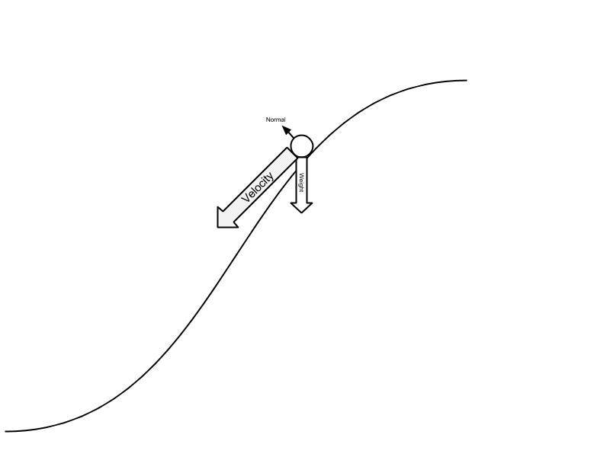

Figure : Free Body Diagram Top of Drop

With an enormous velocity, very little force is actually exerted on the track which would create the normal force. This occurs up until the inflection point.

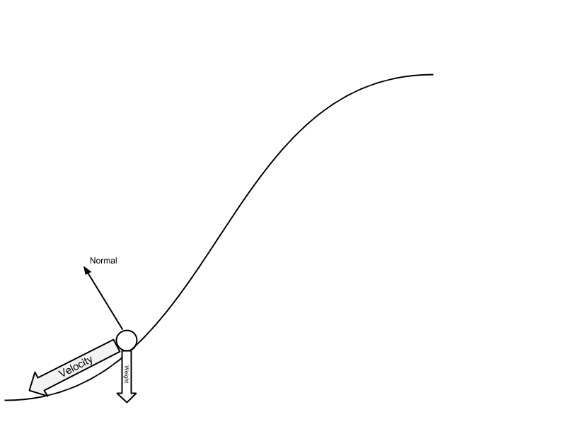

Figure : Free Body Diagram Bottom of the Drop

There, the angle of the track is such that the normal force counteracts the weight of gravity which allows the marble to move along the bend.

# 6. Testing and Building Methods

## 6.1 Testing

### 6.1.1 Marbles

To help ensure a consistent run of the coaster, the marbles were sorted based on both size and mass to help create a consistency in the marbles. The results of the test are below:

Table : Marble Diameters and Masses

|  |  |  |
| --- | --- | --- |
| Marble | Diameter | Marble Mass |
| 1 | 0.668 | 4 |
| 2 | 0.677 | 4 |
| 3 | 0.668 | 4 |
| 4 | 0.681 | 4 |
| 5 | 0.669 | 4 |
| 6 | 0.672 | 4 |
| 7 | 0.647 | 4 |
| 8 | 0.669 | 4 |
| 9 | 0.673 | 4 |
| 10 | 0.665 | 4 |
| 11 | 0.649 | 4 |
| 12 | 0.668 | 4 |
| 13 | 0.652 | 4 |
| 14 | 0.669 | 4 |
| 15 | 0.680 | 4 |
| 16 | 0.650 | 4 |
| 17 | 0.647 | 4 |
| 18 | 0.666 | 4 |
| 19 | 0.677 | 4 |
| 20 | 0.669 | 4 |
| 21 | 0.660 | 4 |
| 22 | 0.679 | 4 |
| 23 | 0.675 | 4 |
| 24 | 0.654 | 4 |
| 25 | 0.650 | 4 |
| 26 | 0.641 | 4 |
| 27 | 0.655 | 4 |
| 28 | 0.672 | 4 |
| 29 | 0.688 | 4 |
| 30 | 0.680 | 4 |
| 31 | 0.679 | 4 |
| 32 | 0.683 | 4 |
| 33 | 0.669 | 4 |
| 34 | 0.674 | 4 |
| 35 | 0.677 | 4 |
| 36 | 0.654 | 4 |
| 37 | 0.661 | 4 |
| 38 | 0.673 | 4 |
| 39 | 0.667 | 4 |
| 40 | 0.661 | 4 |
| 41 | 0.669 | 4 |
| 42 | 0.686 | 4 |
| 43 | 0.677 | 4 |
| 44 | 0.667 | 4 |
| 45 | 0.686 | 4 |
| 46 | 0.673 | 4 |
| 47 | 0.668 | 4 |
| 48 | 0.693 | 4 |
| 49 | 0.679 | 4 |
| 50 | 0.691 | 4 |

Table : Marble Diameter Statistics

|  |  |
| --- | --- |
| Average | 0.669 |
| STDev | 0.012 |
| Mode | 0.669 |
| Skew | -0.354 |

As easily noticeable by these statistics, the marbles are very consistent in width, with a very small standard deviation of only 0.012. Also, as noticed by the skew, with the little variation that there are in the marbles, most of the marbles tend to be larger with a couple outliers on the smaller portion of the spectrum. Unfortunately, the most precise scale availible gave its readouts in grams with no decimal precision. So while differences in mass are noticeable in the marbles, it is impossible for us to find the amount of differences.

**6.1.2 Efficiency**

To get an accurate representation of the efficiency of the coaster, a test was conducted. The test consisted of timing the marble as it rolls down a straight segment of track. The set-up looked like the following:

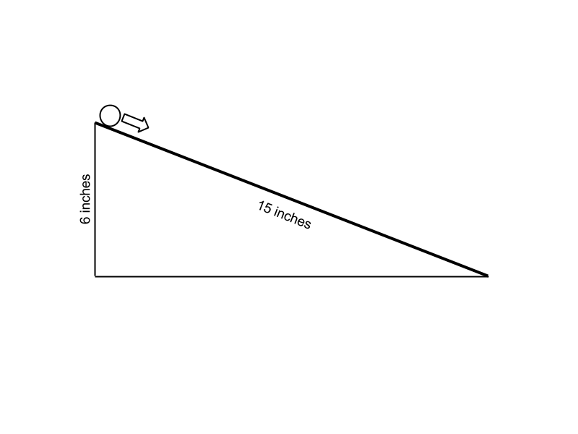

Figure : Efficiency Test Set-up

The times it takes for the marble to roll down the 15 inches are shown below:

Table : Efficiency Test Times

|  |  |
| --- | --- |
| Trial | Time |
| 1 | 1.33 |
| 2 | 0.84 |
| 3 | 1.01 |
| 4 | 0.76 |
| 5 | 0.85 |
| 6 | 0.76 |
| 7 | 0.78 |
| 8 | 0.88 |
| 9 | 0.86 |
| 10 | 0.80 |
| 11 | 0.78 |
| 12 | 1.01 |
| 13 | 0.74 |
| 14 | 0.90 |
| 15 | 1.00 |
| 16 | 1.16 |
| 17 | 0.69 |
| 18 | 0.93 |
| 19 | 0.95 |
| 20 | 0.75 |

To figure out which time we wished to use, the statistics were used to determine the optimal time. Because the skew was very high, this indicated that the median instead of the mean would be a more accurate time to do the calculations with.

Table : Efficiency Test Statistics

|  |  |
| --- | --- |
| Stats |  |
| Mode | 1.01 |
| Median | 0.86 |
| Average | 0.89 |
| STDev | 0.16 |
| Skew | 1.36 |

From there, simple math using the Law of Conservation of Energy can be used to calculate the theoretical time.

$$mgh=\frac{1}{2}mv^{2}+\frac{1}{2}ωI$$

$$mgh=\frac{1}{2}mv^{2}+\frac{1}{2}{\left(\frac{v}{r}\right)}^{2}\int_{0}^{M}{r^{2}dm}$$

$$mgh=\frac{1}{2}mv^{2}+\frac{1}{2}{\left(\frac{v}{r}\right)}^{2}\left[\frac{2}{5}mr^{2}\right]$$

$$mgh=\frac{1}{2}mv^{2}+\frac{1}{5}mv^{2}$$

$$gh=\frac{1}{2}v^{2}+\frac{1}{5}v^{2}$$

$$gh=\frac{7}{10}v^{2}$$

$$\frac{10}{7}gh=v^{2}$$

$$\frac{10}{7}gh={\left(\frac{a}{t}\right)}^{2}$$

$$t=\frac{a}{\sqrt{\frac{10}{7}gh}}$$

$$t=0.67$$

Where h is the height (6 inches), g is acceleration due to gravity (9.81 m/s2), and a is the acceleration down the ramp. It was calculated as shown below.

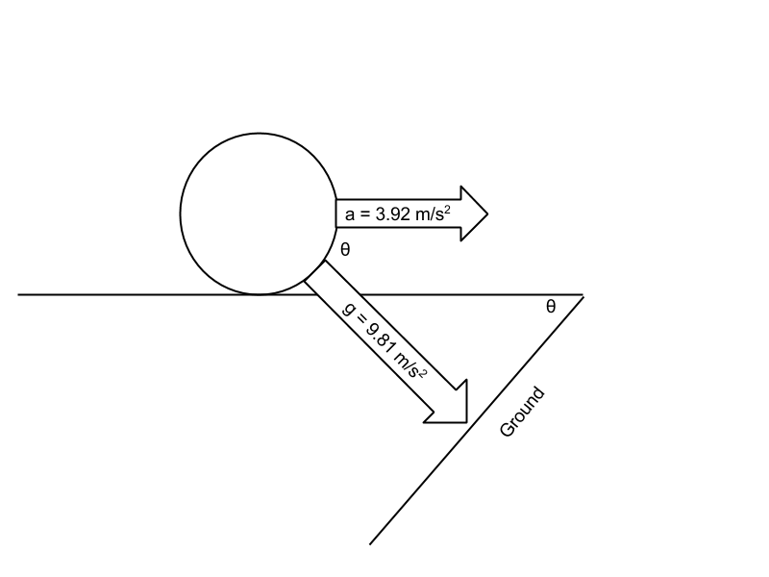

Figure : Efficiency Test Acceleration Calculation

By shifting the axis to align with the plane, it allows for easy calculation of the acceleration.

## 6.3 Failure Analysis

### 6.3.1 Straw Failure

In an effort to choose the strongest straws for the coaster, both 5 inch and 7 inch straws were tested in both dimension consistency and strength using a three-point stress test. The results of the test are below:

Table : Straw Failure Results

|  |  |  |  |
| --- | --- | --- | --- |
| Straw | Inner Diameter (mm) | External Diameter (mm) | Max Force (N) |
| 7-inch |  |  |  |
| 1 | 2.9 | 3.2 | 0.099 |
| 2 | 2.8 | 3.1 | 0.610 |
| 3 | 2.9 | 3.3 | 0.687 |
| 4 | 2.9 | 3.3 | 0.670 |
| 5 | 2.9 | 3.4 | 0.556 |
| 6 | 2.8 | 3.1 | 0.604 |
| 7 | 2.9 | 3.2 | 0.709 |
| 8 | 2.8 | 3.2 | 0.772 |
| 9 | 2.9 | 3.3 | 0.624 |
| 10 | 2.9 | 3.1 | 0.845 |
| 11 | 2.9 | 3.2 | 0.769 |
| 12 | 2.8 | 3.3 | 0.594 |
| 13 | 2.7 | 3.0 | 0.594 |
| 14 | 2.8 | 3.1 | 0.755 |
| 15 | 2.8 | 3.1 | 0.636 |
| 16 | 2.9 | 3.3 | 0.616 |
| 17 | 2.8 | 3.1 | 0.616 |
| 18 | 2.9 | 3.1 | 0.909 |
| 19 | 2.9 | 3.2 | 0.699 |
| 20 | 2.7 | 3.2 | 0.780 |
|  |  |  |  |
| 5-inch |  |  |  |
| 1 | 3 | 3.1 | 0.769 |
| 2 | 3.4 | 3.6 | 0.700 |
| 3 | 3.2 | 3.4 | 0.756 |
| 4 | 3.2 | 3.3 | 0.748 |
| 5 | 3.2 | 3.5 | 0.888 |
| 6 | 3.2 | 3.3 | 0.811 |
| 7 | 3.1 | 3.6 | 0.799 |
| 8 | 3.2 | 3.3 | 1.020 |
| 9 | 3.2 | 3.4 | 0.992 |
| 10 | 3.2 | 3.4 | 0.929 |
| 11 | 3.2 | 3.5 | 0.895 |
| 12 | 3.2 | 3.4 | 0.992 |
| 13 | 3.2 | 3.5 | 0.573 |
| 14 | 3.3 | 3.6 | 0.881 |
| 15 | 3.2 | 3.5 | 0.741 |
| 16 | 3.1 | 3.4 | 0.604 |
| 17 | 3.2 | 3.4 | 0.800 |
| 18 | 3.2 | 3.4 | 0.822 |
| 19 | 3.1 | 3.3 | 0.731 |
| 20 | 3.3 | 3.5 | 0.757 |

As noticeable by the data, the 5 inch straws are not only clearly stronger, but also have much greater consistency than the 7 inch straws, making them the ideal choice for the coaster.

### 6.3.2 Bonding Methods

The general method of bonding including cutting a short segment of straw and sticking into the two straws and then securing the bond. There was, however, testing needed to see at what point these bonds would break with several different gluing materials. The two that were tested were super glue and hot glue. These were tested by connecting a force gauge onto one end of two connected straws and pulling until the connection broke. The entire time, the force exerted on the straws was recorded. Below is a table of all the max forces experienced on the connections.

Table : Bonding Methods Results

|  |  |  |
| --- | --- | --- |
|  | Super Glue | Hot Glue |
| 1 | 15.61 | 26.23 |
| 2 | 7.52 | 42.77 |
| 3 | 8.665 | 16.13 |
| 4 | 17.48 | 25.05 |
| 5 | 7.918 | 59.02 |
| 6 | 10.49 | 63.85 |
| 7 | 9.241 | 16.30 |
| 8 | 6.731 | 55.35 |
| 9 | 6.461 | 24.37 |
| 10 | 19.37 | 40.36 |
| 11 | 10.32 | 48.57 |
| 12 | 10.76 | 56.77 |
| 13 | 16.66 | 25.28 |
| 14 | 7.443 | 61.07 |
| 15 | 19.27 | 53.75 |
| 16 | 15.66 | 62.19 |
| 17 | 20.13 | 53.41 |
| 18 | 8.237 | 46.23 |
| 19 | 29.16 | 36.60 |
| 20 | 9.152 | 55.48 |

Table : Bonding Methods Statistics

|  |  |
| --- | --- |
| Super Glue | Hot Glue |
| #N/A | #N/A |
| 10.405 | 47.40 |
| 12.8139 | 43.44 |
| 6.053469078 | 16.04753429 |
| 1.136928139 | -0.4603600608 |

Additionally, during the hot glue testing, three of the straws broke before the connection, which implies that the connections with super glue are more than adequate for the situation. One additional advantage of the hot glue is that given heat, all bonds can be reversed and fixed.

# 7. Mathematical Analysis

# 8. Design Validation

**8.1 Provided Constraints**

*Reliability: A glass, standard size marble, must roll down on top of the straws at least 10 consecutive times in a row*

Our coaster has demonstrated reliability in successful marble drops.

*Size restrictions - the base must have a minimum width and length of 50 cm (representing 500m)*

The board is currently 121x121cm

*Need a solid wood board for the basecut in the shape of your coaster footprint.*

We have a solid plywood board, of 121x121cm supporting the entire coaster.

*Supports can be out of any material of your choice*

The straw track is supported by a combination of wooden dowels secured through wooden blocks, and wooden rollercoaster like scaffolding, holding up the track from the terrain rather than the base board (which will change less with movement)

*Topography should be clearly shown in your model*

Our coaster had extensive work put in, modelling the terrain of our chosen location. We followed the path of the river through the area, along the cliff, and into the outer bay area. We neglected to include forestry or other disruptive foliage, in order to emphasize the track itself.

*The entire track must fit within the footprint, with the track area maximized (calculations prove the track area is optimized)*

We covered the majority of the border, and our model does not accurately represent the final design plan. Our final design will include a chain-driven track, pulling the cart up the side hill (currently looks unused, but is a flat slope), to be dropped off the top point. The bottom unused corner will also be utilized, acting as the loading/unloading station for passengers.

*The track design must represent a continuous function, be open (no tunnels, gluing track down onto boards, sticks, etc),be designed to support a standard size glass marble (no shooter marbles/metal balls) that rolls on top of the straws (not in between straws or supported by any rails), and model a wooden roller coaster.*

We designed the entire coaster using glass marbles, of on average 0.669cm width. The entire track does not go through any tunnels, or under anything other than itself at 2 points. The track is glued down to perpendicular sticks acting as wooden support, but only in similar ways to crossbeams supporting rails. No supports parallel to the track such as wooden boards are present. There are no sticks/wires/foam/expansive material filling the straws throughout. The support system we use heavily models after an actual wooden roller coaster.

*This means that glass marble when released from the top of the first hill by the judge will travel through the entire ride, and arrive at the bottom loading platform without stopping or jumping the track (track must be modeled by continuous and differentiable functions)*

The track is a continuous function. While not all points are easily modelled, the function is continuous, no breaks. The marble does not stop at any point once released from its initial point. The marble does not jump the track at any point, unless pushed at release by the releaser, in which case it’s possible for the velocity to be high enough to cause a slight jump on the main drop.

*The ball must remain in contact with the track at all times. The following are prohibited: free-fall of the marble, uncontrolled movement through a funnel, frisbee, disc or similar. If there is a question about legality of a design, questions may be posed to Mrs. Clemmer or Mr. Eno*

The ball will stay on the track, unless pushed down rather than released. Assuming a normal release, the marble will never leave contact with the track.

*Engineering of the track: There must be 2 loops, one spiral/corkscrew,  and 2 distinct interlocking elements*

Our original design included a double loop (2 loops at the same time, one immediately following the other), immediately following our main massive drop. We assumed that such a drop would provide the necessary speed for a double loop. When the track works, the loops work. We have a spiral, in the form of a spring with the bottom dragged out. For interlocking elements, we found creating these elements was detrimental to the entire coaster, resulting in possible failure. For these reasons, we include only one partial interlocking segment, with the coaster doubling under itself at multiple points.

*The design must incorporate at least 3 different and distinct continuous and differentiable functions. One of the functions must include at least 2 periods of either a cosine or sine function*

We have 3 different, distinct, continuous and differentiable functions. Among these are an inverse cubic function, a sine function (including 2 periods), and a quartic polynomial function. These functions were found through measuring specific points on the graph, and confirming the graph matched the model.

*At the end of the ride the marble must trigger a device that uses a minimum of 10J of energy.  The device must tie into the theme and brings closure to the ride. Magnets, electricity, hydraulics, pneumatics, springs and other forms of energy can be used.  All uses of other forms of energy must be submitted and approved before the PDR.*

The marble will trigger a small light show, simulating water rushing down the river, before filling the river/delta, and then giving off light to show off the local terrain.

## 8.2 IAAPA Constraints

*The IAAPA takes its regulations, along with ISO 9001 (both international standards, with EN 13814 being the standard for European amusement parks).*

*5.2.1.4 Calculations shall be performed using coordinate axis and load paths as defined by Practice F 2137 or the EN equivalent, (x,y,z) ie: x and y are both parallel to the ground, perpendicular to each other, while z is vertical*

Our model and calculations follow these goals.

*5.4.1 The designer/engineer or manufacturer shall produce and retain as-built drawings, calculations, and control software that depict the amusement ride, device, or major modification details. These drawings and calculations shall be retained for a minimum of 20 years from the date of last manufacture. In the case of a major modification, only the records associated with that major modification, and not the entire ride or device, must be retained for a minimum of 20 years.*

We are retaining these documents, with a copy in paper being delivered to the government of La Isla de Coca, a paper copy being retained in our firm, an online copy being stored on Google’s data servers, and a copy being stored in an offline server on multiple computers, and ESHS Gaming (owned by Pen Island Squad).

*5.4.4.3 Detailed drawings of all components specifically manufactured for use in the amusement ride, device, or major modification.*

The full details, including scans and copies, will be stored in the same manner as addressed in 5.4.1

*5.5.1 When the approval of the amusement ride, device, or major modification design is required by a regulatory authority, the following documents are typically  made available for review:*

*5.5.1.1 General assembly drawings,*

*5.5.1.2 Facility interface drawings and related load calculations,*

*5.5.1.3 Operations, maintenance, and assembly instructions*

These documents, and all details under 5.5.1.* will be available, in the same fashion as described in the response to 5.4.1

*6.3.8.3 Special tools shall not be required to operate the manual release,  unless otherwise determined by the  ride analysis.*

The release of the cart shall be simplified to dropping a marble in an easily repeatable manner, without requiring any special tools, or anymore than the simplest basic training.

*7.1.4.5 The limits  specified for all axes are for total net acceleration, inclusive of earth's gravity. A motionless body would therefore have a magnitude of 1 G measured in the axis perpendicular to the earth's surface, and a 0 G magnitude in the axes parallel to the earth's surface.*

We are taking into consideration for the object, a constant acceleration of 1G along the Z axis, and a horizontal acceleration of 0 G by default along the X and Y axes.

*7.1.6.1 The peak-to-peak transition time between consecutive sustained events in X and Y accelerations shall be greater than 200 ms, as measured by the time between the peaks of the consecutive events. When the elapsed time between consecutive sustained events is less than 200 ms, the limit for the peak values shall be reduced by 50 %.*

This means that any event’s maximum G-force cannot occur within 200ms of another event’s maximum G-force, unless that second G-force is less than or equal to 50% of the acceleration of the initial peak. The spacing between the events of our coaster lead to this not being an issue.

*7.1.7.2 Other transitions  in Z accelerations are shown in Fig. 20. The following criteria shall apply: When transitioning from sustained weightless (0 G) and more negative levels to 2 G and more positive levels, the effective onset of positive G shall be less than 15 G/s. Fig. 20 illustrates such transitions.*

In English, after any moment when Gs are less than or equal to 0, the jerk to return to positive Gs, or general jerk in the positive direction must be less than 15 G/s. As of our current model, the jerk of the entire track is less than 3G/s in magnitude.

*7.1.8 Measurement and analysis of acceleration on amusement rides and devices shall be performed in accordance with Practice F 2137. The design acceleration levels  of the  final operational assembly of a newly developed amusement ride, device, or major modification shall be verified at commissioning. The manufacturer may verify acceleration limits herein by using either manual (for example, graphic, hand calculations, and so forth) or automatic (for example, computational, computer, and so forth) procedures.*

Acceleration values, limits, and other data was obtained through computer measurement of the roller coaster every 10ms of its trip.

F2291 - 06a - Fig. 11-18 Repeated

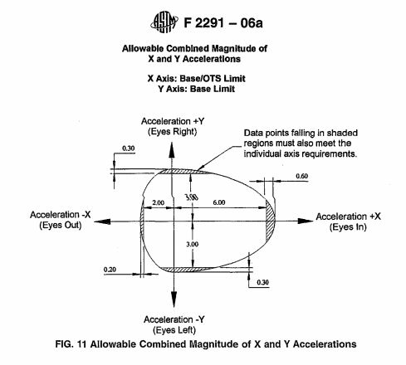

Figure 30:F2291 - 06a - Fig. 11

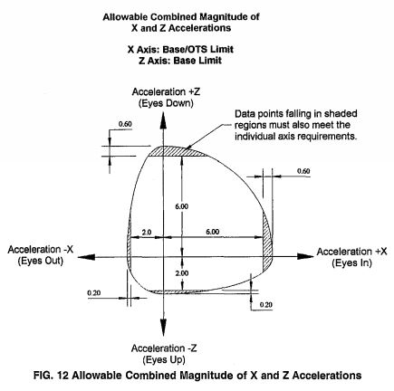

Figure 31:F2291 - 06a - Fig. 12

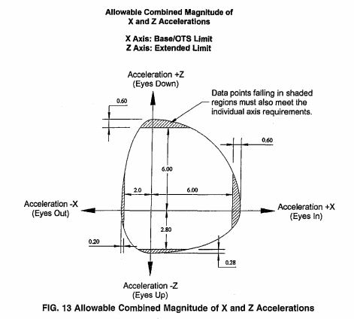

Figure 32:F2291 - 06a - Fig. 13

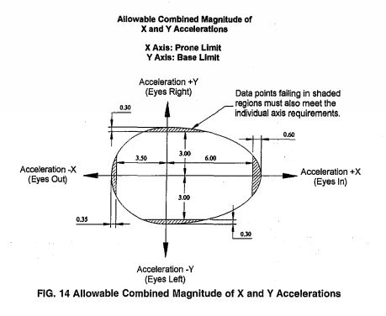

Figure 33:F2291 - 06a - Fig. 14

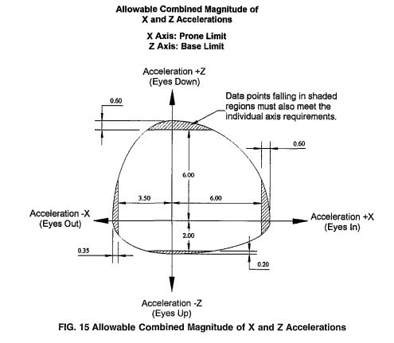

Figure 34:F2291 - 06a - Fig. 15

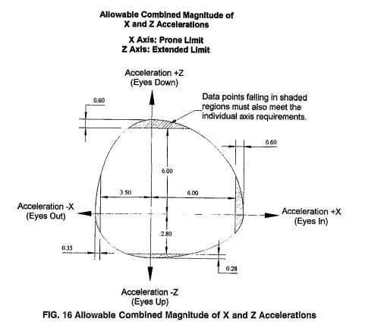

Figure 35:F2291 - 06a - Fig. 16

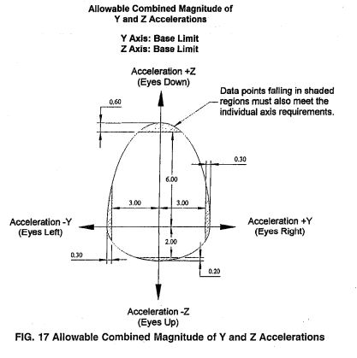

Figure 36:F2291 - 06a - Fig. 17

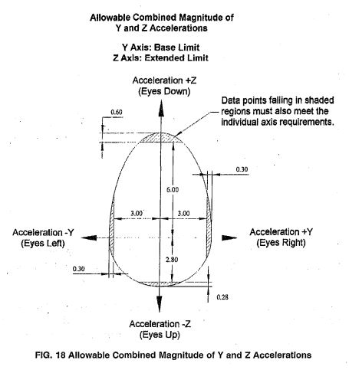

Figure 37:F2291 - 06a - Fig. 18

What these figures state, is that the max acceleration vertically for a duration over 200ms (or recurring peaks) must be less than 6.6 Gs, and greater than -2 .2Gs. The horizontal acceleration (relative to the rider) must be less than 6.6 Gs, and greater than -2.2 Gs, under the same time constraints. Our simulation shows that while all these limits are breached, they are not breached for more than 200ms, being impact acceleration as opposed to sustained acceleration

*\*\*See figure from constraint 7.1.6.1\*\**

*8.33.4.1 Inspection for damaged or missing paint and the presence of moisture; any situations where water might enter and become trapped,  supporting the  development of rot or insect damage, or failure from expansion due to ice formation, and recommended methods of examinations required to determine the presence and extent of rot in timber members.*

The damage by rot or insect is prevented by the strict use of treated wood, as opposed to very weak soft wood, which is where typical damage is done. Regarding the water damage (as we are building in a rain forest, over a river and around a waterfall), we’ll also have a coated layer on each wooden piece protecting from water. On top of this, a layer of primer and paint will be on top of every visible surface.

*13.2.2 Chain and related accessories shall be selected and designed for designer/engineer specified loads, speed, corrosion, operating environmental and dynamic conditions, and for wear and fatigue.*

We are outsourcing the design of this chain to Gold Safety and Consultation, and if the chain fails all liabilities will be transferred to that particular firm.

*13.2.3 Chain manufacturer's specifications shall include dimensions, strength,  grade, and nominal breaking strength working load limit, and shall be included in the maintenance instructions.*

See 13.2.2

*13.2.4 The capacity of the chain and related accessories, for example, terminations, adapters, shall be verifiable by certificates, manufacturer's markings, or testing.*

See 13.2.2

### 8.3 Ecological Constraints

*The coaster shall not disturb any plants or animals in such a way that a decrease in population, food supply, or water supply could upset the ecosystem or endanger any plants or animals.*

The area we affect is very well optimized, with minimal support being used (running the track along more barren cliff as opposed to over more populated flat terrain). The river will not be affected in any way, not even a single support being put in the water, no flow interruptions, nothing. There will be a small upset in individual animals, but the species on the island will not be affected.

*The coaster shall not pollute any water sources with any foreign chemicals.*

The river we cross over will not be touched, nor any waste products be dumped.

*Only the plants necessary for building the roller coaster or rider safety shall be removed. Additionally, this number shall be kept at a minimum.*

A minimal number of trees will be removed, with the most prominent amount being at the top of the coaster before the drop down the cliff. Even here, tree removal is minimized, to preserve the environment both as a visual advantage for riders, and for conservation of nature reasons. Only where the roller coaster path goes, and where supports are necessary, will there be any trees removed.

*The type of materials used shall not be able to affect the surrounding ecosystems.*

The primary building materials will be steel rails for holding the cart, fixed to a wooden support structure, built 100% from polished, sealed, and treated wood. The polish and seal on this wood will prevent the chemicals used in treating wood from leaking into the surrounding ecosystem.

*The coaster shall not produce an excess of 5 tons per year of*

1. *carbon monoxide*
2. *lead*
3. *nitrogen oxides*
4. *particulate matter (TSP or total suspended particulates)*
5. *sulfur dioxide*
6. *volatile organic compounds (VOCs)*
7. *toxic air pollutant*

The only chemical noteworthy of being tracked is carbon monoxide from the generators required to operate the pull chain pulling the cart up the hill, and the air brakes to stop its descent at the end. The output that is provided will be by a motor about double the strength of the average car, yielding roughly double the annual tonnage output of a car (575 pounds), or roughly 1150 pounds annually, nowhere near the 5 ton limit.

# 9.0 Theoretical Vs. Actual

Theoretical:

We initially had large plans for our coaster. Starting with a simple horizontal sine function as opposed to the standards vertical sine, we would slowly and snakelike move along the cliff through forestry, until finally creeping up the drop, and plummeting down to through a heart-wrenching double loop, conserving momentum and climbing back up the cliff, before acceleration through a wide triple spiral and finally popping out through the double loop to the end.

Actual:

In practice we met some problems meeting the majority of these goals. The horizontal sine function had to be scrapped, as making consistent and smooth curves was almost infeasible, so we decided to go with a simpler vertical sine function molded using boiling water. This vertical sine gave us more control over the direction and changes for our actual track, along making calculations and (lack of) banks easier.

The drop was surprisingly accurate, in regard to our theoretical versus our actual. We encountered some difficulty in making a drop that wasn’t too steep, but found the issues to be predominantly in the entrance and exit of the drop, as opposed to the slope itself. We found some difficulty in consistently not jumping off the track, but there was always at least one ideal speed that the track would work at.

The loop was much more difficult. Firstly, a double loop sucks up a lot of energy if it’s not perfectly ideal, so a large amount of time was spent making a perfect loop, with it eventually being remade 3 times after its initial creation. We tried shrinking the loop, redirecting the turns, and slight tilts on the entrance/exit to get as near ideal of a loop as we could. The main difficulty came from not having enough speed along the second loop, result in it not hugging the track the entire time, and dropping while travelling upside down. This was the focus of our time spent on actual track, and we went through many modifications, from track design methods, to size variants, to angles of entry and exit. Predominantly, this was our most challenging segment.

The spiral after was a piece of cake, after we realized our failure. The marble did not have enough energy exiting to pass through the double loop as originally intended and perform a spiral, so we had to make do with a spiral and then passing under the track and intersecting with the supports, where the wooden dowels actually came in handy.

Overall, there were many notable differences between our theoretical and ideal. For one, the track was not efficient in regard to energy conservation. While perhaps a straight line conserved a large portion of energy, curved track, with many more bumps (that we sanded out and smoothed down), lost significantly more energy. This led to many features throughout, such as a steeper slope at the beginning, a MUCH smaller double loop, a complete cancellation of the return up the mountain for the spiral, and a complete cancellation of the intersecting segments. In a more ideal situation, more time could have eliminated many of these problems, but our building times were effectively limited up to 11pm, and often earlier than this.

# 6. Resources

Cocos Island National Park [Internet]. [UNESCO] United Nations Education, Scientific, and Cultural Organization; c1992-2015 [cited 2015 May 15]. Available from:<http://whc.unesco.org/en/list/820>

The World Factbook [Internet]. [CIA] Central Intelligence Agency; c2015 [cited 2015 May 15]. Available from:<https://www.cia.gov/library/publications/the-world-factbook/geos/cs.html>

CPI Inflation Calculator [Internet]. [CIA] United States Department of Labor; c2015 [cited 2015 May 15]. Available from:<http://data.bls.gov/cgi-bin/cpicalc.pl>

Psyclone – Six Flags Magic Mountain [Internet]. [RCDB] Roller Coaster Database; c1996-2015 [cited 2015 May 15]. Available from: [http://rcdb.com/27.htm](http://rcdb.com/27.html)

Colossus – Six Flags Magic Mountain [Internet]. [RCDB] Roller Coaster Database; c1996-2015 [cited 2015 May 15]. Available from:<http://rcdb.com/26.htm>

Apocalypse the Ride – Six Flags Magic Mountain [Internet]. [RCDB] Roller Coaster Database; c1996-2015 [cited 2015 May 15]. Available from:<http://rcdb.com/4173.htm>

How the Average American Family Spends Their Income – And How They Trim It [Internet]. [SD] The Simple Dollar; 2014 [cited 2015 May 16]. Available from:<http://www.thesimpledollar.com/how-the-average-american-family-spends-their-income-and-how-to-trim-it/>

Number of households in the U.S. from 1960 to 2014 (in 1,000) [Internet]. [S] Statista; 2014 [cited 2015 May 16]. Available from:<http://www.statista.com/statistics/183635/number-of-households-in-the-us/>

The Business of Building Roller Coasters [Internet]. [P] Priceonomics; 2014 [cited 2015 May 18]. Available from:<http://priceonomics.com/the-business-of-building-roller-coasters/>

How Much Does it Cost to Build a Single-Family House? [Internet]. [F] Fixr; c2015 [cited 2015 May 19]. Available from:<http://www.fixr.com/costs/build-single-family-house>

Building Process [Internet]. [CR] Costa Rica; c1996-2015 [cited 2015 May 19]. Available from:<http://costarica.com/real-estate/building-process/>

Codes and Compliance: Demystifying the Door Opening [Internet]. [AADSS] ASSA ALBOY Door Security Solutions; 2014 [cited 2015 May 20]. Available from:<http://www.assaabloydss.com/Local/DSS/ASSAABLOYCodeResourceHandbook_FINAL.PDF>

Designation: F 2291 - 06a (US). 2012. Standard Practice for Design of Amusement Rides and Devices [Internet]. American Society for Testing and Materials International (US); 2006 [cited 2015 May 16]. Available from<https://law.resource.org/pub/us/code/ibr/astm.f2291.2006.pdf>

Leithold L. 1996. The calculus 7 of a single variable. 6th ed. Connors K., Geller R., Netzel D. editors. New York. HarperCollins Coll Publishers. 698 p.

Department of Ecology DE. 2012. Air Quality Fee Rules. [Internet]. [2012 Nov 30, cited 2015 May 20] Vol(1):Washington State. Available from: fortress.wa.gov/ecy/publications/documents/173455.pdf

United States Environmental Protection Agency . April 2000. Average Annual Emissions and Fuel Consumption for Passenger Cars and Light Trucks [Internet]. 1.US EPA; [April 2000, cited 2015 May 20] . Available from:<http://www.epa.gov/otaq/consumer/f00013.pdf>

Open-Source OS. 2015 April 26 . Cheat Engine [Internet]. 6.3.DBVM; [2015 April 26, cited 2015 May 20] . Available from:<http://cheatengine.org/index.php>

Roller Coaster Loop Shapes [Internet]. [UoG] University of Gothenburg; c2005 [cited 2015 May 22]. Available from:<http://physics.gu.se/LISEBERG/eng/loop_pe.html>

Caesalpinia Bonducella F - An Overview [Internet]. [GCoP] Govt. College of Pharmacy; 2010 [cited 2015 May 22]. Available from: <http://www.sciencepub.net/report/report0203/13_2487_komal_report0203_83_90.pdf>

Review on Pharmacological Properties of Caesalpinia Bonduc L. [Internet]. [OAS] Open Access Science; 2012 [cited 2015 May 22]. Available from: <http://www.openaccessscience.com/pdf-files/vol2_3_sept2012/IJMAP_2_3_21_caesalpinia_bonduc.pdf>

Roller Coaster Loops [Internet]. [PC] Physics Classroom; c1996-2012 [cited 2015 May 22]. Available from: <http://www.physicsclassroom.com/getattachment/reasoning/circularmotion/src17.pdf>

Rollercoaster Loop Shapes [Internet]. [DoPGU] Department of Physics, Göteborg University; 2005 [cited 2015 May 22]. Available from: <http://physics.gu.se/LISEBERG/eng/pe5601.pdf>

Hibiscus Titialceus [Internet]. [CTAHR] College of Tropical Agriculture and Human Resources, University of Hawai’i at Mãnoa; 2003 [cited 2015 May 22]. Available from: <http://www.ctahr.hawaii.edu/invweed/WeedsHI/W_Hibiscus_tiliaceus.pdf>

Moment of Inertia [Internet]. [H] Hyperphysics; n.d. [cited 2015 May 22]. Available from: <http://hyperphysics.phy-astr.gsu.edu/hbase/mi.html#mi>

Work-Energy Principle [Internet]. [H] Hyperphysics; n.d. [cited 2015 May 22]. Available from: <http://hyperphysics.phy-astr.gsu.edu/hbase/rotwe.html>